You’ll See
By
Branar

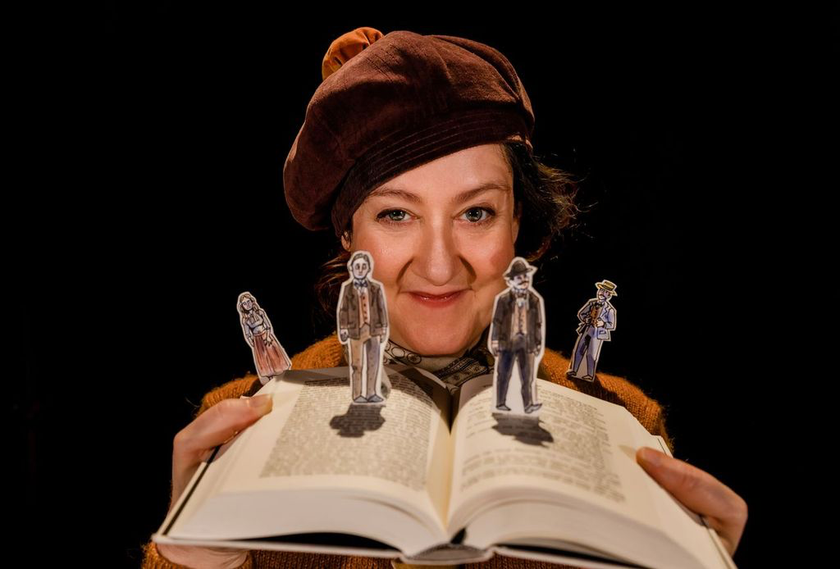

BELFAST CHILDREN’S FESTIVAL 2025
Teacher’s Resource

TABLE OF CONTENTS

About Young at Art ……………………..............…………………page 3

How to use this Resource …………............…………………….page 4

Learning Intentions ……………….............……………………….page 5

Curriculum Links ………………….............………………………..page 5

Summary of You’ll See…………...................…………….........page 7

Cast and Crew …………………...............………………………....page 8

Pre-Show Activities …………………..............…………………….page 9

Planning to go!………..….........................................………...page 9

True or False……….……...........................……………………...page 10

One day in the City…………………....................………………..page 11

Post-Show Activities …………...............………………………….page 13

Thinking Back………………..........................................……..page 13

Go with the flow………….....................……….…………………..page 14

About Us

Young at Art is one of Northern Ireland's leading children's arts not-for-profit companies and home of Belfast Children's Festival in Belfast's city centre, Young at Art coordinates not only an international festival and a touring events agency, but also a wide variety of projects that encourage children and young people under 18 to enjoy the arts.

Young at Art believes passionately that every child should have the right to access exciting and original creative experiences, regardless of who they are or where they come from. The company believes that arts provision should be FOR children and young people, as well as BY children and young people.

‘You’ll See’ Resource was compiled by Education & Engagement Co-ordinator Becca Wilson and Education & Engagement Assistant Katie Davies. This resource includes curriculum-based lessons and activities designed and was developed by Stranmillis University College student-teacher Thérèse Rainey.

To find out more about Young at Art, our performances and resources, please view our website www.youngatart.co.uk. Alternatively, contact our Education & Engagement Co-Ordinator on 028 9023 0660 or educationcoordinator@youngatart.co.uk

HOW TO USE THIS RESOURCE

This resource is intended to support teachers whose pupils are engaging with a performance of ‘You’ll See’ during Belfast Children’s Festival 2025. It outlines pre- and post-performance activities that can be utilised to both prepare pupils for the performance and enable them to unpack and process the experience afterwards. While the pre-performance exercises will greatly aid the appreciation of the production, it is also extremely beneficial for pupils to be given the opportunity post-performance to explore the elements of the show and what they thought and felt about it. The performance can be used as a starting point for a number of exercises and lesson development long after the original experience.

The pre-performance activities outlined in this resource are designed to prepare your pupils for attending this performance. The activities can serve as warm-up games and exercises that engage the children in creative thinking, quick physical responses to suggestions, and experimenting with performance. It’s also helpful to introduce the vocabulary and skills which will maximise children’s engagement with the performance on the day and help to shape their critical responses. The suggested activities below include both active experimentation with performance, more reflective exercises based on teaching by questioning, and practical cross-curricular activities which explore themes within ‘You’ll See’. The pre-performance activities can be reflected upon as a class and used to illustrate key concepts the children might encounter in a live theatre performance.

These concepts include:

- Themes of loneliness and negative emotion
- Exploring alternative ways to create music
- Exploring daily routine
- The use of artistic visual elements, e.g., light, shape, colour etc. to represent dreams and abstract ideas

If children are familiar with these concepts before experiencing a performance, there will be less of a 'shock factor' when they encounter them onstage. This leads to a deeper appreciation of the performance they will see.

Post-performance activities aim to elicit responses from the pupils by encouraging critical appraisal of the performance they have seen as a class. The activities allow the students to explore how they felt about the performance, what they remember, and what they thought of it. They also act as tools that can be used to encourage the children to express their own ideas and emotions in a safe, imaginative and creative way. Both sets of activities are intended to be adapted by teachers as they see fit to suit their own and their classes’ needs and interests. The cross-curriculum potential is endless!

Learning Intentions

Pupils will be encouraged to:
- Work on their talking and listening skills
- Work with physical materials to create art
- Perform and play musical rhythms
- Develop their emotional awareness
- Work on time management

CURRICULUM LINKS

Experiencing different forms of live theatre and performance provide the opportunity for different modes of learning within the curriculum. These experiences include the independent experience as an audience member, cooperative learning through group discussion and group play, and practical activities pre- and post-performance.

Specific curriculum links which can be made to ‘You’ll See’ at varying levels include:

KS1 & 2
Art and Design
- Use thoughts and ideas as the basis for visual work
- Investigate colour and texture
- Work with the visual elements to explore and create visual outcomes, talk about and comment on what they produce
- View examples of art
- Use what they have seen as a stimulus or starting point for Individual ideas and personal interpretations
- appreciate how to use mark making materials

Music
- Work creatively with sound
- Talk about the sounds they hear
- Perform with simple instruments
- Listen and respond to own and other’s music

Language and Literacy
- Talking about experiences, pictures and stories
- Use of social language
- Observing modelled behaviours
- Talking about their work, play and things they have made
- Recalling
- Sequencing
- Asking and answering questions
- Describing
- Explaining
- Sharing their thoughts, feelings and ideas with different audiences
- Taking part/contributing to group oral language activities
- Listening and responding to adults and peers

Personal Development and Mutual Understanding
- Encouraged to develop a positive attitude to learning
- Expressing how they feel
- Themselves and their personal attributes
- Recognising their own and others’ feelings and emotions
- Recognising what they can do
- Beginning to recognise how they feel
- Developing ways of expressing how they feel
SUMMARY OF YOU’LL SEE

Duration: 35 minutes
Age: 8+

James Joyce’s epic story of one day in one city is brought to life in this inventive new show, bringing Ireland’s most notorious book to audiences aged 8 and upwards.

Ulysses for Children? Yes. Yes, Ulysses for Children. James Joyce’s epic story of one day in one city is brought to life in this inventive new show, bringing Ireland’s most notorious book to audiences aged 8 and upwards, and to all those who haven’t got around to reading it yet. Combining Branar's signature storytelling, intricate paper design, an original score and Joyce’s odyssey, this is theatre that will excite both young and old. Originally commissioned by and produced as part of Ulysses 2.2, a collaborative project between ANU, Landmark Productions and Museum of Literature Ireland.

Cast and Crew

Performer…………………………….……Helen Gregg

Director…………………….……Marc Mac Lochlainn

Producer………………………….……Jonanne Beirne

Composer…………………….……….Michael Chang

Book Design and Creation……..….Maeve Clancy

Sound Design…………………………….Adrian Ferry

Costume Design………………..……..Elaine Mears

Cinematography…………………………James Ryan

Set Build……………………….………….Ciaran Kelly

Paper Creation…………..…….Sorcha Ní Chróinín

Stage-Manager………………..……..Debbie Wright

Line Producer…………………Niamh Ní Fhlatharta

Social Media Marketing………….…Noel Minogue

Production Assistant…………….…….Nóra Burke

Design Assistant……………….…….Oisín Parslow

Ulyssess 2.2 Project Manager……………..Gráinne Pollak

PRE-SHOW ACTIVITIES

To prepare children for viewing the show

Activity 1: Preparing to Go!

Set up: Move all the desks, pupils sit in a circle on the floor

Specific curriculum links: The Arts; Language Development; Early Mathematical Experiences; Personal, Social and Emotional Development; The World Around Us.

How to play:

- Generate a discussion with the children about shows. Have they ever been to any or seen any on tv before? Talk about shows aimed at children they might have attended like the pantomime or school plays.

- What kinds of things did the characters do? What can they remember from their experiences?

- Next, ask the children to think about their emotions regarding the upcoming performance. What are their concerns/ questions? How can these be addressed before they go? Layout clear expectations both for their own behaviour and what they are likely to experience. This is useful to ensure you as the teacher have prepared for any scenario

- Get them excited! What are they most looking forward to?

Skill Outcomes:
Increased ability to:
- recall events and details
- critical Thinking
- offer and express independent opinions
- think creatively and imaginatively
- empathise
- concentrate, listen and observe
- respect each other’s opinions

Activity 2: True or False

Set up: Regular classroom setting

Specific curriculum links: The Arts; Language Development; Early Mathematical Experiences; Personal, Social and Emotional Development; The World Around Us.

How to play:
- Children may not know who James Joyce is, if they do, they may have little knowledge.
- This activity is a fun way for children to learn, in a relaxed setting and it won’t be too much information to take in at once.
- The teacher will have facts about James Joyce written out on pieces of card. Once read out to the class, the teacher can ask the children if they think it is true or false.
- The children can then raise their hands and take guesses.

Skill Outcomes:
Increased ability to:
- recall events and details
- critical Thinking
- concentrate, listen and observe
- respect each other’s opinions

Activity 3: One Day in the City

Set up: Regular classroom setting

Specific curriculum links: The Arts; Language Development; Early Mathematical Experiences; Personal, Social and Emotional Development; The World Around Us.

How to Play:
- Pass out a sheet of paper to every child.
- Ask the children to think about how they would spend their time, if they had one day to spend in Dublin.
- Ask the children if have they ever been to Dublin before. If so, did they like it? What did they not like about it?
- What would they do if they could spend the day by themselves? Would they like to be by themselves in a city? Why/why not?
- They can also imagine a day in a different city if they would prefer.
- Get them to write out these thoughts, with no rhyme or reason, a stream of consciousness.

Skill Outcomes:
Increased ability to:
- recall events and details
- critical Thinking
- offer and express independent opinions
- think creatively and imaginatively
- empathise
- concentrate, listen and observe
- respect each other’s opinions

POST-SHOW ACTIVITES
To unpack the experience of the Show

Activity 1: Thinking Back

Set up: Usual classroom setting

Specific curriculum links: The Arts; Language Development; Personal, Development and Mutual Understanding.

How to play
- Generate a discussion with the children about the show. What do they remember about it? What were the most important/funniest/ most enjoyable parts of the show? When did the lights change? Why? How did the music make you feel?

- What kinds of things did the characters do? What types of movement/acrobatics can they remember? How did the character move from one side of the page to the other?

- The teacher can then ask each child to talk about their favourite moment and further explore the pupils’ positive memories of the performance: Why did you like this? What made it funny? Were there any other parts that haven’t been mentioned that you liked?

- Next, ask the children to think about the emotions from the performance. When were there happy/sad moments etc.? Did the lighting affect the emotions in the performance? What did they think about the way the character moved? What did they think when the character started making a ‘mess’?

- The exact same process is then repeated with the question: What was your least favourite part of the show? What did you like about the artwork at the end? Explain it is ok if they did not like parts of the show and everyone is entitled to their own opinion.

Skill Outcomes
Increased ability to:
- recall events and details
- offer and express independent opinions
- think creatively and imaginatively
- empathise
- concentrate, listen and observe
- respect each other’s opinions
- identify elements from the show such as shapes, objects, movements

Activity 2: Go with the Flow

Set up: Move all the desks, pupils sit in a circle on the floor

Resources: Paper (1 per child), crayons/pens

Specific curriculum links: The Arts; Language Development; Personal Development and Mutual Understanding.

How to play
- Start a discussion with the children about when things don’t go to plan. Ask the children to discuss with the person beside them a time when something didn’t go the way they wanted it to.

- How did the children feel when it didn’t go to plan? How did they react to the situation?

- Next, give each child a piece of paper and something to draw with (e.g., a crayon or a pen). The children will begin to draw a picture on their paper but after 1 minute stop the children and instruct them to pass the paper to the person to their right.

- Then the children will continue the drawing on a piece of paper they did not start with.

- Continue to stop the children every minute and pass the paper around the circle until the time is up.

- The finished products should look completely different than the first child intended.

Skill Outcomes
Increased ability to:
- Offer and express opinions
- Respect the opinions of others
- Acknowledge everyone makes mistakes
- Understand their own feelings

This resource is the copyright of Young at Art 2025 and should not be reproduced or distributed to any third party. It is solely for use in educational settings in conjunction with the performance of “You’ll See”.

