Relaxed Performance Social Story | The Lyric Resource



Velveteen Rabbit
by
Replay Theatre Company


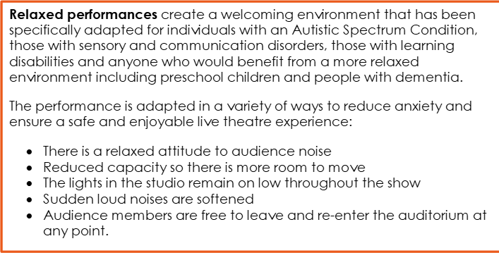


Velveteen Rabbit is 90 minutes long with an interval.

· Velveteen Rabbit is performed in the Lyric Main Stage. This area has seating and standing space. The Naughton studio is fully adaptable with light, sound & projection on request.

· There’s no right or wrong way to watch Velveteen Rabbit, we want you to enjoy it! That means you can wriggle and make a noise.

· If at any time you would like to take a break you can take a step away from the performance area or leave the theatre and come back when whenever you’re ready. An usher will be there to help you.

· The Ushers are there to help you. If you need to leave during the show an Usher will ensure you are ok. They can also show you where the toilets are. Ushers are good people to go to if you feel worried about anything in the show. You can speak to them before, during or after the performance.

QUIETER SPACES

We have dedicated several spaces across our building for you if you need to take some time out of the performance. Simply ask an Usher to help you get where you’d like to be.

· There is a dedicated Quiet Room, away from noise and people, with somewhere to sit and fully take time.

WHEN THE SHOW BEGINS…AND WHAT TO EXPECT!

- The lights dim when the show is about to start
- Performers come on stage to begin the show
- People around you may quiet down in anticipation
- You will experience various sights and sounds during the show
- Expect laughter, clapping, and cheering

- It is important that children or youngsters feel free in order to make the most of the experience.
- Velveteen Rabbit aims to develop out of the NON-intervention of grown-ups / relatives in the free exploration of the audience.
- The title of this project differs from the original show because the experience and the dialogue that result from it are also different, aiming to widen our horizons.

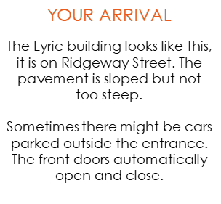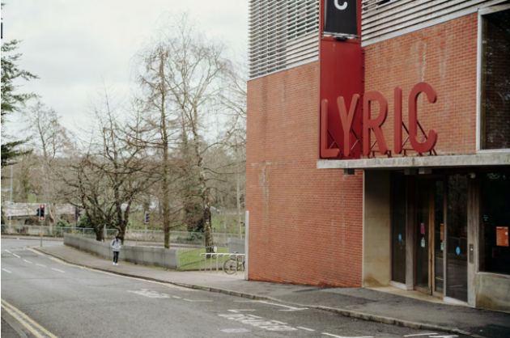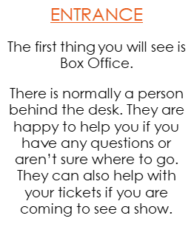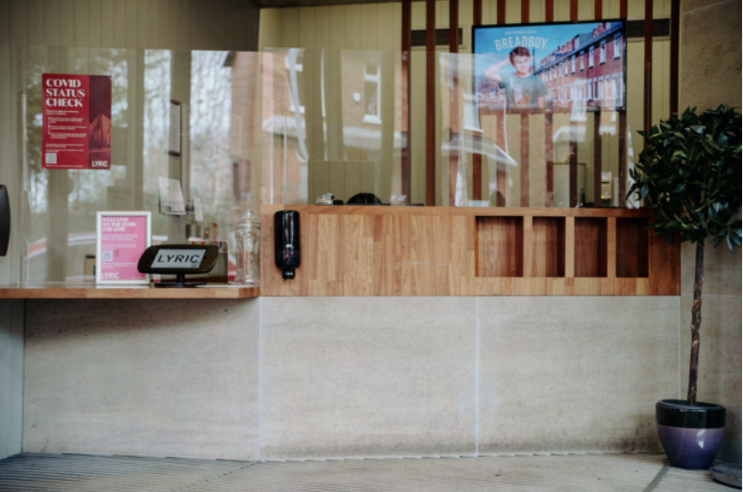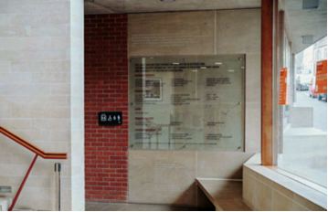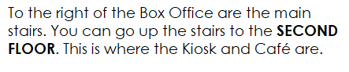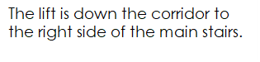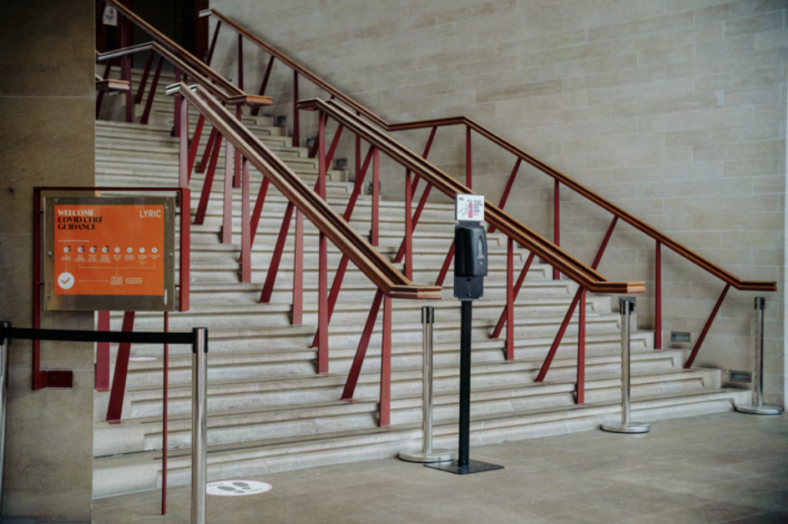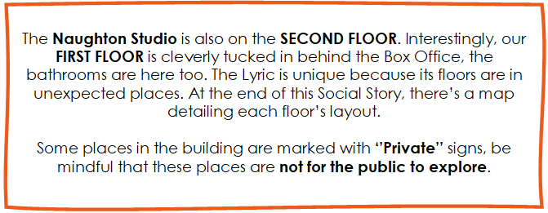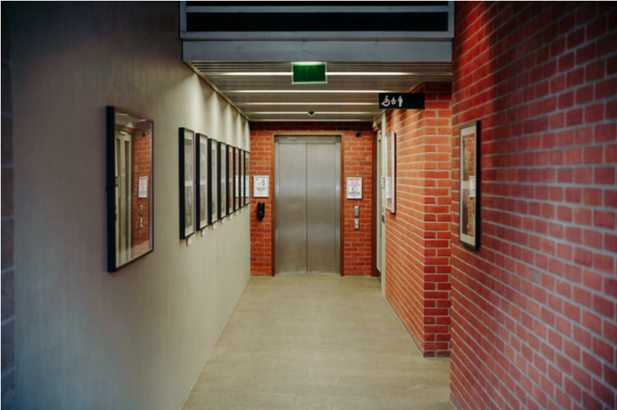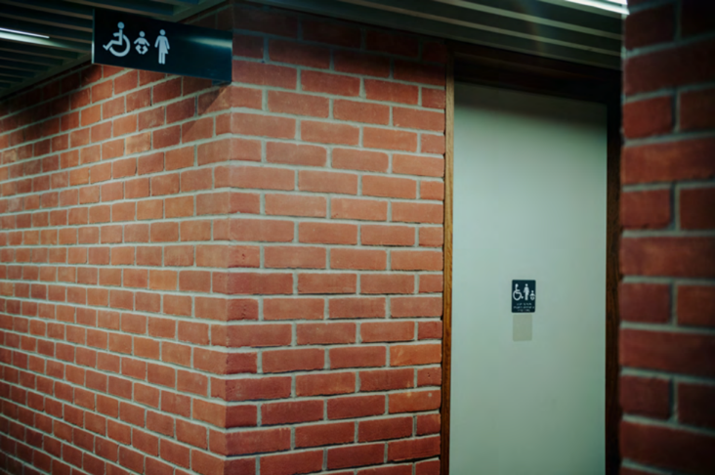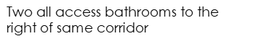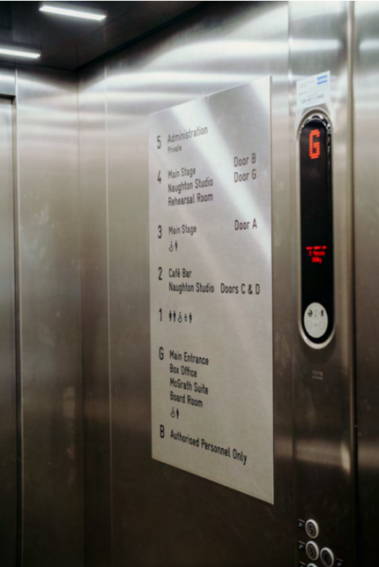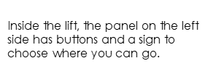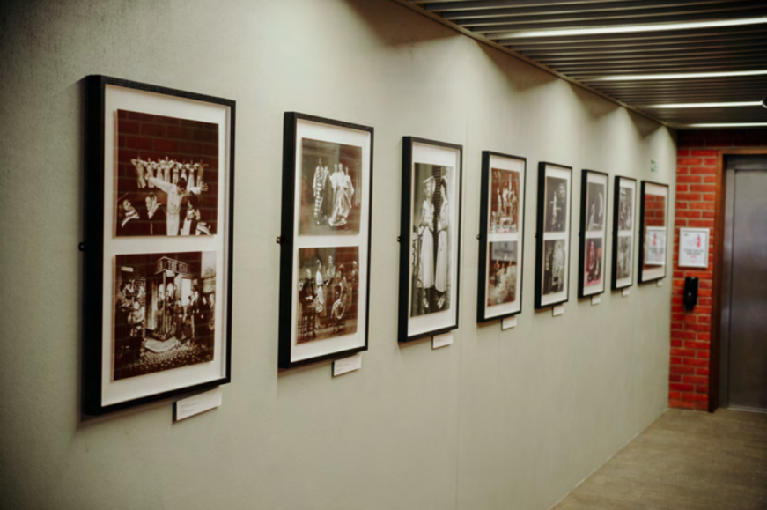

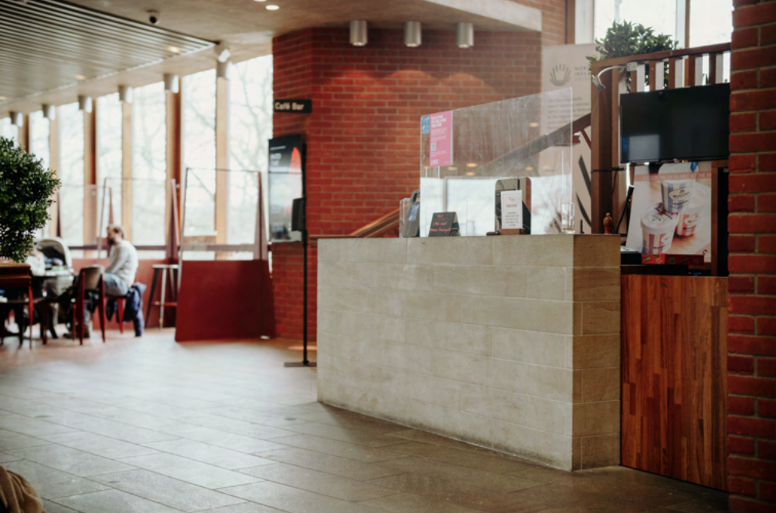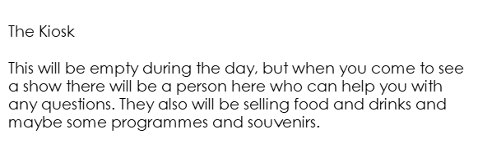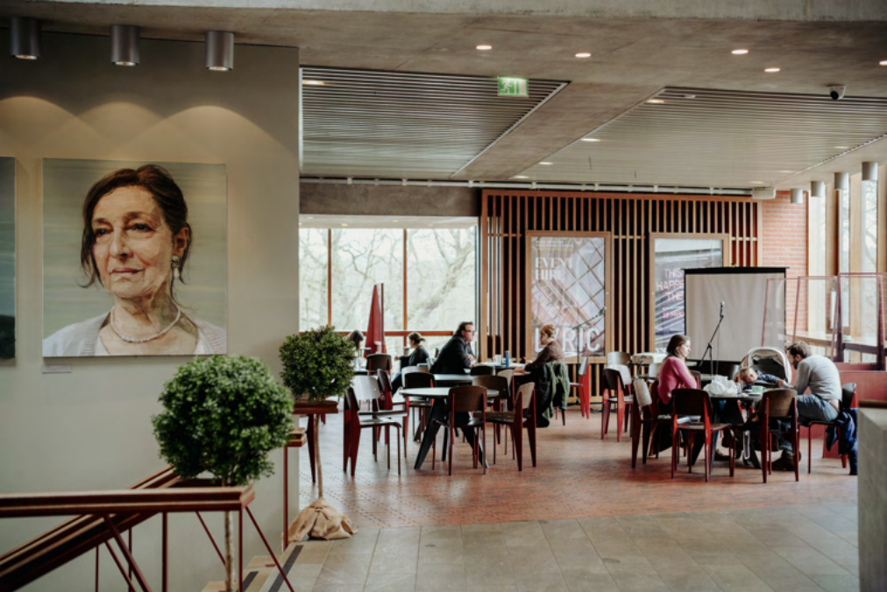
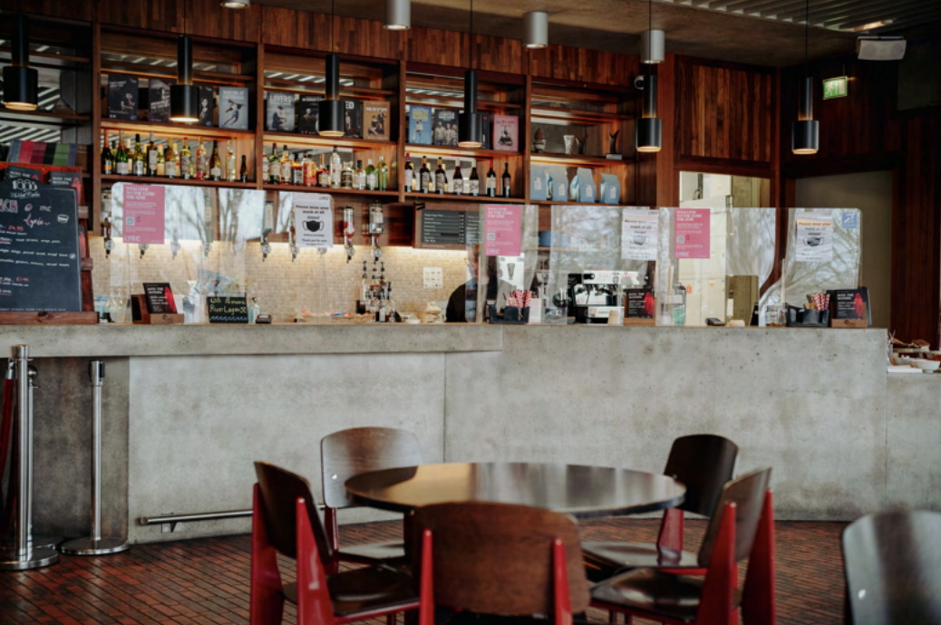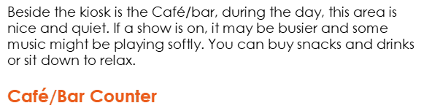
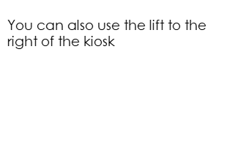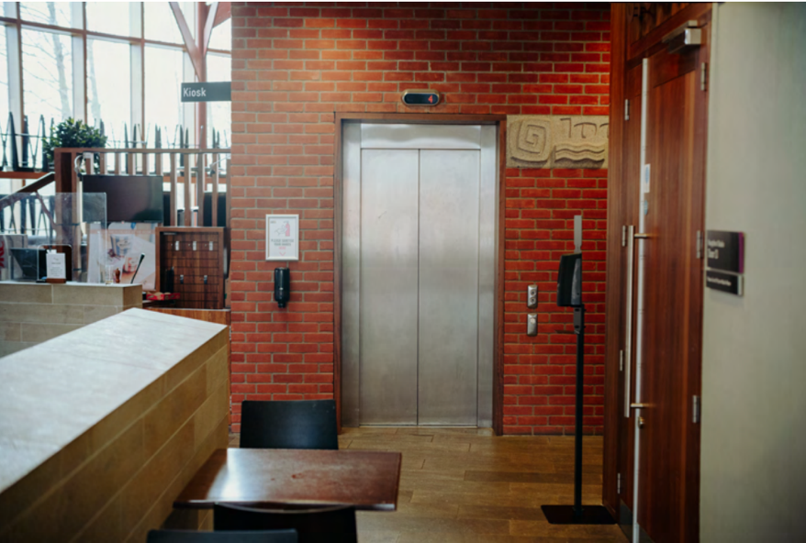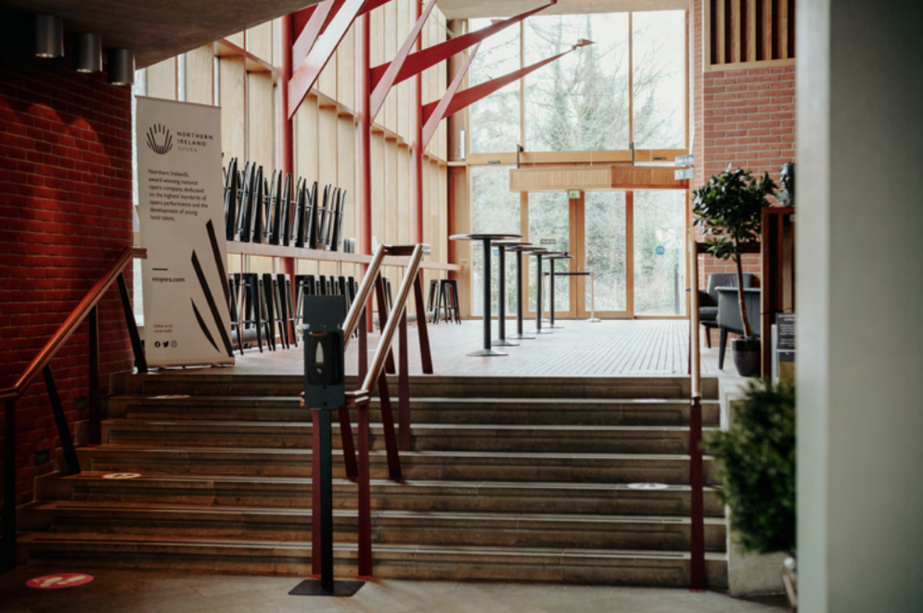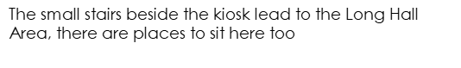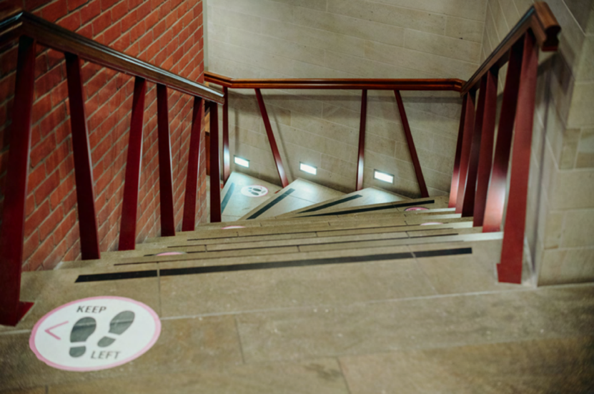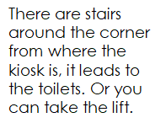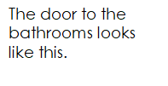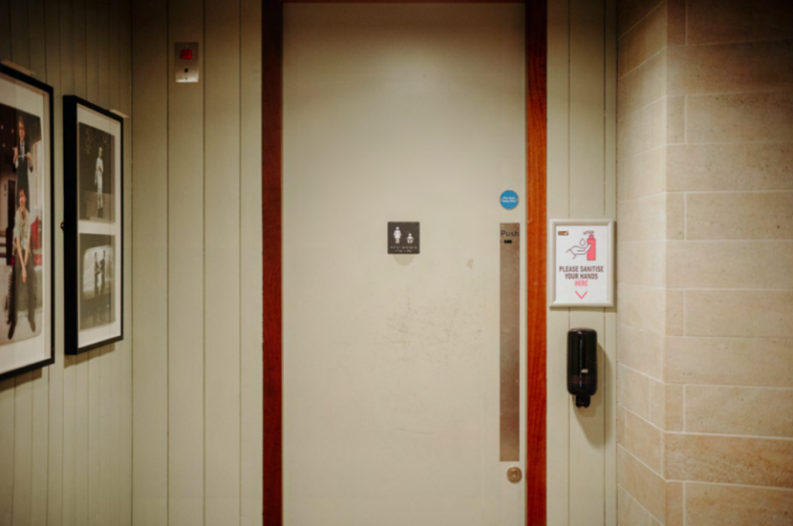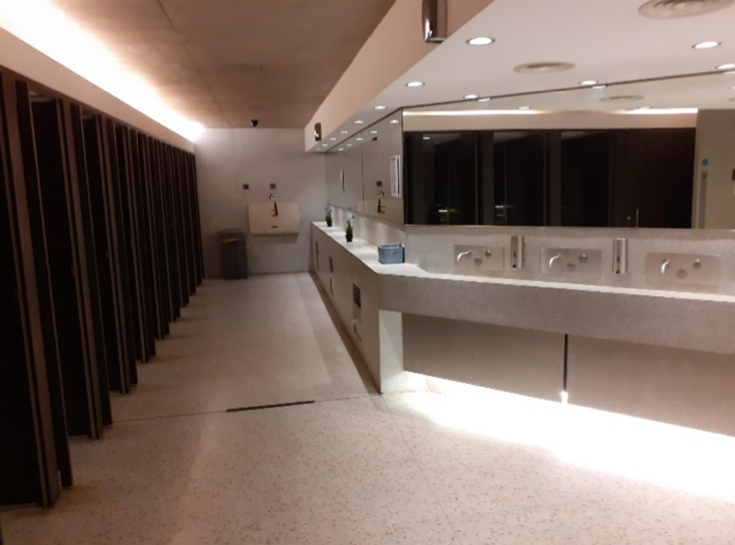
SHOW TIME
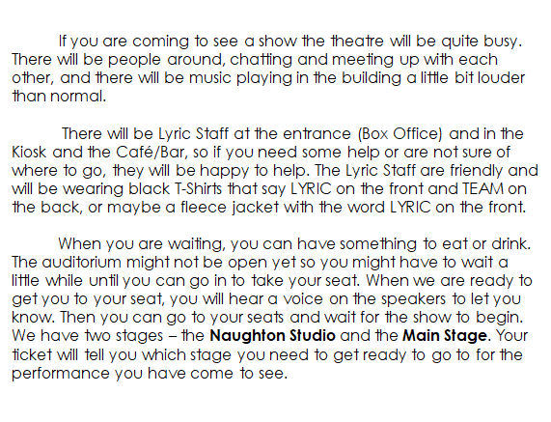
NAUGHTON STUDIO

WHERE YOUR SHOW TAKES PLACE…

