

The Bench
By
Teater Refleksion

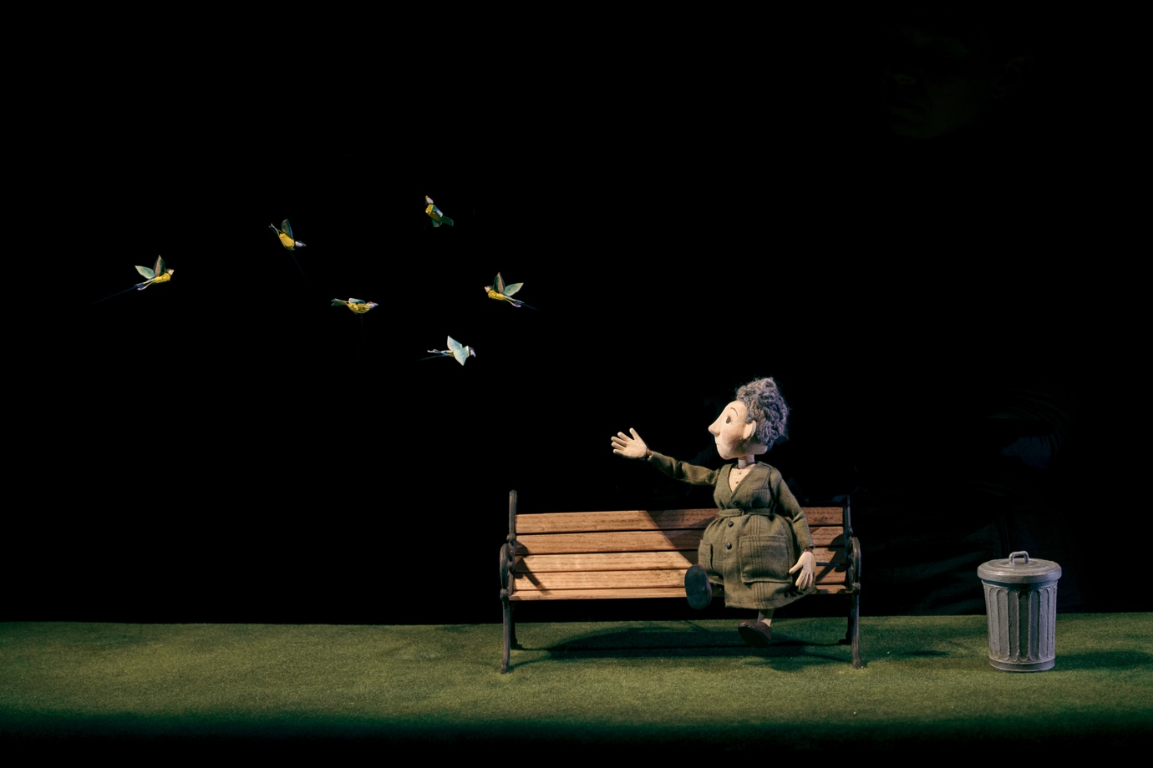

BELFAST CHILDREN’S FESTIVAL 2025
Teacher’s Resource

TABLE OF CONTENTS

About Young at Art ………………………………………page 3

How to use this Resource ………………………...….page 4

Learning Intentions ………………………….......……page 5

Curriculum Links …………………………...…………..page 6

Summary of The Bench………............................page 9

Cast and Crew ………………………….......………....page 10

Pre-Show Activities …………………………...……….page 11

Preparing to Go! ……..……........................……...page 11

Walk Through the Woods…………….....…….……….page 12

Post-Show Activities …………...……...….………….page 13

Thinking Back………………..........................……..page 13

Go with the Flow..... ...……..……….…...…..………..page 14

Magical Bench.........…...…………….…..…....………page 15

This resource is the copyright of Young at Art 2025 and should not be reproduced or distributed to any third party. © Young at Art 2025

About Us

Young at Art is one of Northern Ireland's leading children's arts not-for-profit companies and home of Belfast Children's Festival, which celebrates its 27th Anniversary in 2025. From its base in Belfast's city centre, Young at Art coordinates not only an international festival and a touring events agency, but also a wide variety of projects that encourage children and young people under 18 to enjoy the arts.

Young at Art believes passionately that every child should have the right to access exciting and original creative experiences, regardless of who they are or where they come from. The company believes that arts provision should be FOR children and young people as well as BY children and young people.

The Bench Resource was compiled by Education & Engagement Coordinator Becca Wilson and Education & Engagement Assistant Katie Davies. This resource includes Curriculum based lessons and activities designed and was developed by Stranmillis University College BEd Primary student, Jessica Lowry.

To find out more about Young at Art, our performances and resources, please view our website www.youngatart.co.uk. Alternatively, contact our Education & Engagement Officer on 028 9023 0660 or education@youngatart.co.uk

HOW TO USE THIS RESOURCE

This resource is intended to support teachers whose pupils are engaging with a performance of The Bench during Belfast Children’s Festival 2025. It outlines pre- and post-performance activities that can be utilised to both prepare pupils for the performance and enable them to unpack and process the experience afterwards. While the pre-performance exercises will greatly aid the appreciation of the production, it is also extremely beneficial for pupils to be given the opportunity post-performance to explore the elements of the show and what they thought and felt about it. The performance can be used as a starting point for several exercises and lesson development long after the original experience.

The pre-performance activities outlined in this resource are designed to prepare your pupils for attending this performance. The activities can serve as warm-up games and exercises that engage the children in creative thinking, quick physical responses to suggestions, and experimenting with performance. It’s also helpful to introduce the vocabulary and skills which will maximise children’s engagement with the performance on the day and help to shape their critical responses. The suggested activities below include both active experimentation with performance, more reflective exercises based on teaching by questioning, and practical cross-curricular activities which explore themes within The Bench. The pre-performance activities can be reflected upon as a class and used to illustrate key concepts the children might encounter in a live theatre performance.

These concepts include:

- The use of non-verbal communication
- Understanding the symbolism of props and animating them through action
- The use of mime within drama and everyday life
- Responding to types of light and sound
- The use of imagination
- Exploring different types of synchronised and contrasting dance movements
- The use of artistic visual elements, e.g., line, shape, colour, construction etc.
- Concept of creative licence and freeness to make messes with creative outputs.
- Respond to the flow of mood during a performance, from concentration to chaos

If children are familiar with these concepts before experiencing a performance, there will be less of a 'shock factor' when they encounter them onstage. This leads to a deeper appreciation of the performance they will see.

Post-performance activities aim to elicit responses from the pupils by encouraging critical appraisal of the performance they have seen as a class. The activities allow the students to explore how they felt about the performance, what they remember and what they thought of it. They also act as tools that can be used to encourage the children to express their own ideas and emotions in a safe, imaginative and creative way. Both sets of activities are intended to be adapted by teachers as they see fit to suit their own and their classes’ needs and interests. The cross-curriculum potential is endless!

Learning Intentions

Pupils will be encouraged to:
- Express opinions, ideas and emotions
- Experiment with performance
- Explore body movements
- Develop creativity
- Expand their imaginations and creativity
- Work individually (focus, recall, thinking creatively and critically)
- Make predictions and decisions (based on a range of cues and information)

Curriculum Links

Experiencing different forms of live theatre and performance provide the opportunity for different modes of learning within the curriculum. These experiences include the independent experience as an audience member, cooperative learning through group discussion and group play, and practical activities pre- and post-performance.

Specific curriculum links which can be made to The Bench at varying levels include:

Foundation Stage
Art and Design
- expand their visual imagination when given a minimalistic stimulus
- understand the multipurpose of simple creations
- use thoughts and ideas as the basis for visual work
- work with the visual elements and exaggerated actions to explore and create visual outcomes, talk about and comment on what they produce
- use what they have seen as a stimulus or starting point for individual ideas and personal interpretations
- Simple geometric formations

Language and Literacy
- talking about experiences, pictures and stories
- talking about their work, play and things they have made
- Recalling
- Sequencing
- asking and answering questions
- Describing
- Explaining
- sharing their thoughts, feelings and ideas with different audiences
- taking part/contributing to group oral language activities
- listening and responding to adults and peers

Personal Development and Mutual Understanding
- encouraged to develop a positive attitude to learning
- themselves and their personal attributes
- recognising their own and others’ feelings and emotions
- recognising what they can do
- beginning to recognise how they feel
- developing ways of expressing how they feel
- realising that rivalry can be overcome by communication and understanding
- beginning to understand the interdependent nature of the class/school community and themselves as participant members

Physical Development and Movement
- experiment with different ways of moving and exploring personal and general space
- develop confidence, imagination and some understanding of safety through participating in a range of movement activities
- develop body awareness through varying body movements in relation to shape, levels, pathways (straight/curved), directions, speed
- listen and respond to a range of stimuli
- create, practise, improve and perform simple movement sequences which have a clear beginning, middle and end
- observe, describe and copy what others have done

Key Stage 1
Art and Design
- Imaginative world-building beyond the stage. Ability to draw comparisons from simulated artistic props to real life.
- Comment on the visual elements within personal and group responses, such as colours, shapes and patterns
- Comment and draw upon the nature of costume for specific characters.
- Talk about what they have seen, giving personal responses and offering individual interpretations or reactions
- React to what they have seen as a stimulus and use it as a starting point for individual ideas and personal interpretations
- Use the visual elements to explore and create visual outcomes, talk about and comment on what they produce
- Reflect on the experiences of making work, making evaluative comments in relation to their own work
- Discuss work produced with other pupils, comparing their own contributions to group activities with what others have achieved
- Work at a broad range of sizes and scales, and on a variety of supports

Language and Literacy
- Listen to, respond to and explore drama and media.

Personal Development and Mutual Understanding
- Recognise, name and manage their own emotions when given complete freedom to make.
- Understand the emotional benefits of play and fun
- Situate themselves as active audience members, understanding the boundary between watching and participation

Physical Education
- Explore a range of movement skills, including travelling, jumping and landing, rolling,
- Explore, practise and improve body management skills
- Form simple sequences by linking movements
- Use different parts of the body to explore personal and general space and to move using simple actions
- Move in a controlled manner, at different speeds and in different directions, using different levels in space

Summary of The Bench

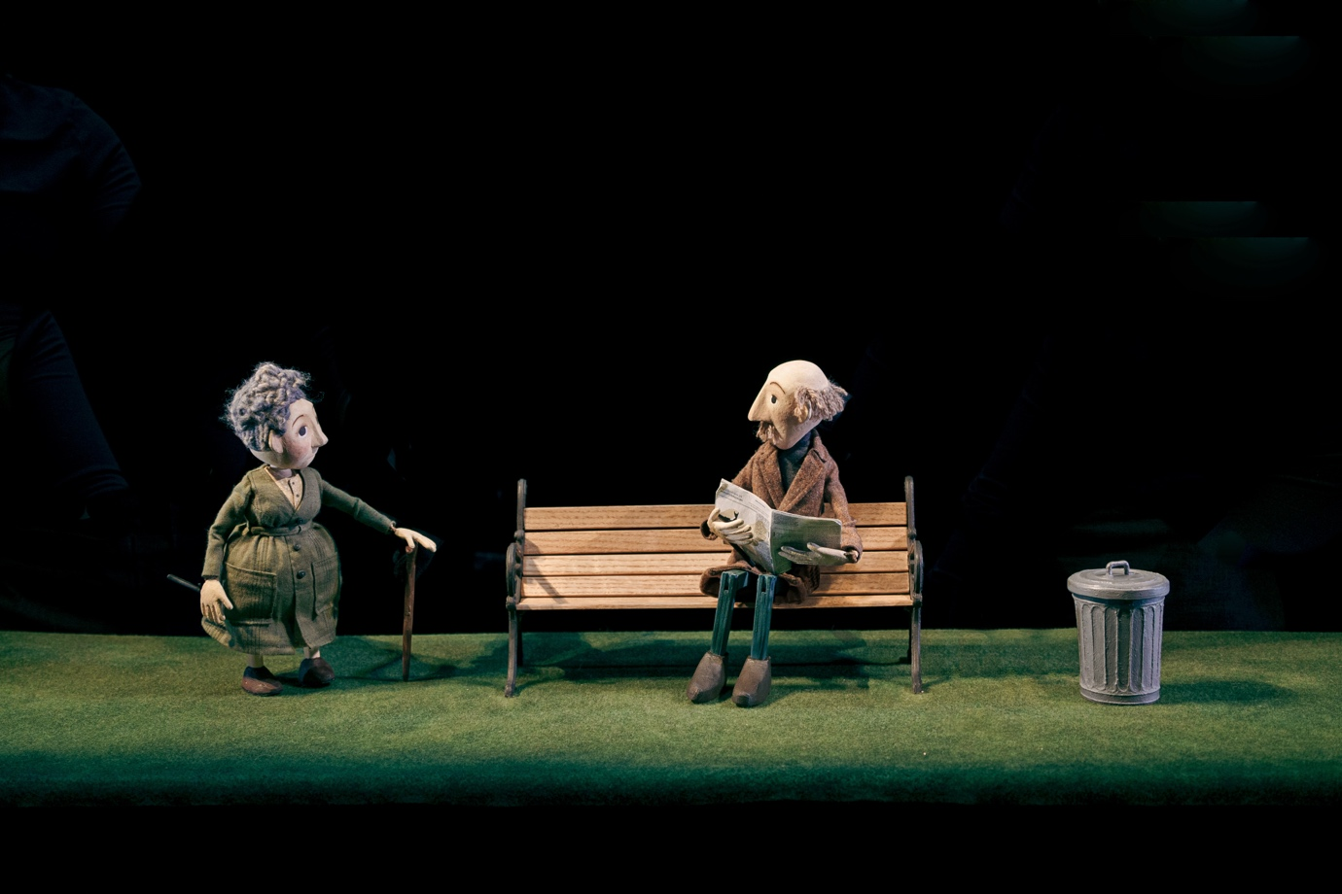
AGE: 6+
DURATION: 40 mins
VENUE: MAC upstairs

A moving and hilarious story about an ordinary day in a bench’s life. It’s so mundane, the bench, and yet so magical! Everywhere in cities, parks and gardens it stands, like an open invitation. Sometimes the bench’s visitors merely brush each other, at other times it evolves. An elderly lady does everything she can to keep life at bay – from her bench. But the hectic surroundings take her by surprise. If only they could let her be old and grouchy alone! But the boy is skateboarding, the dog is sniffing and scuttling around, the birds are chirping, and a friendly, elderly gentleman wants to read his newspaper. All of this is a nuisance!

Cast and Crew

Concept/direction…………......................…………Bjarne Sandborg

Creators/Performers........................................Rebekah Caputo
Maria Garde
Neasa Ni Chuanaigh

Music..............................................Andreas Sandborg, Jacob Venndt

Script................................................................Sven Orno

Set Design/Puppets……................................…Amanda Axelsen Sigaard

Lighting Designer..............................................Morten Ladefoged

Workshop/Tech………. Morten Meilvang Laursen, William Hojberg Nielsen

PRE-SHOW ACTIVITIES
To prepare children for viewing the show

Activity 1: Preparing to Go!

Set up: Move all the desks, pupils sit in a circle on the floor.

Specific curriculum links: The Arts; Language Development; Early Mathematical Experiences; Personal, Social and Emotional Development; The World Around Us.

How to play:
- Generate a discussion with the children about shows. Have they ever been to any or seen any on tv before? Talk about shows aimed at children they might have attended like the pantomime or school plays.
- What kinds of things did the characters do? What can they remember from their experiences?
- Next, ask the children to think about their emotions regarding the upcoming performance. What are their concerns/ questions? How can these be addressed before they go? Layout clear expectations both for their own behaviour and what they are likely to experience. This is useful to ensure you as the teacher have prepared for any scenario
- Get them excited! What are they most looking forward to?

Skill Outcomes
Increased ability to:
- recall events and details
- critical thinking
- offer and express independent opinions
- think creatively and imaginatively
- empathise
- concentrate, listen and observe
- respect each other’s opinions

Activity 2: Walk through the woods

Set up: Collect twigs and foliage from outside to create a park type set in the classroom.

Specific curriculum links: The Arts; Language Development; Early Mathematical Experiences; Personal, Social and Emotional Development; The World Around Us.

How to play:
- Ask the children to imagine that they are going on a walk through the woods. They are going to face ‘challenges’ and encounter things that they may not know how to handle or respond to.
- The teacher will act as a hindrance to the students’ journey, causing them to deal with these “inconveniences” first hand.
- Get creative in how to challenge them!

Unpacking the learning – Questions after the activity
The children should gather a sense of preparing the right tools to overcome a challenge. Draw out comparisons in their own life, where they had to deal with a younger sibling or cousin that provoked or irked them.

Skill outcomes
Increased ability to:
- Handle the unexpected
- critical thinking
- offer and express independent opinions
- think creatively and imaginatively

Building on
In groups the children can act out this scenario themselves and make up their own responses.

POST-SHOW ACTIVITIES
To unpack the experience of the Show

Activity 1: Thinking Back

Set up: Usual classroom setting

Specific curriculum links: The Arts; Language
Development; Personal, Development and Mutual Understanding.

How to play:
- Generate a discussion with the children about the show. What do they remember about it? What were the most important/funniest/most enjoyable parts of the show? When did the lights change? Why? How did the music feel?
- What kinds of things did the characters do? What types of movement/acrobatics can they remember?
- The teacher can then ask each child to talk about their favourite moment and further explore the pupils positive memories of the performance: Why did you like this? What made it funny?
- Ask the children to think about the emotions from the performance. When were there happy/sad moments etc?
- Same process is then repeated – what was your least favourite part of the show?

Skill outcomes
Increased ability to:
- Recall events and details
- Offer and express independent opinions
- Identify elements from the show such as shapes, objects, movements

Building On
This activity can be built upon by asking the children if they were satisfied with the end of the show? Why? Why not?

Activity 2: Go with the Flow

Set up: Move all the desks, pupils sit on a circle on the floor

Resources: Paper (1 per child), crayons, pens

Specific curriculum links: The Arts; Language Development; Personal Development and Mutual Understanding.

How to play:
- Start a discussion with the children about when things don’t go to plan. Ask the children to discuss with the person beside them a time when something didn’t go the way they wanted it to.
- How did the children feel when it didn’t go to plan? How did they react to the situation?
- Next give each child a piece of paper and something to draw with (e.g., a crayon or a pen). The children will begin to draw a picture on their paper but after 1 minute stop the children and instruct them to pass the paper to the person to their right. Then the children will continue the drawing on a piece of paper they did not start with. Continue to stop the children every minute and pass the paper around the circle until the time is up. The finished products should look completely different than the first child intended.
- Discuss how sometimes we do not have control over what is going to happen, however sometimes losing control can result in something even better than the original plan.

Skill outcomes
Increased ability to:
- Offer and express opinions
- Respect the opinions of others
- Acknowledge everyone makes mistakes
- Understand their own feelings

Building On
The children may progress their mark making skills through collaborating on a large-scale, full class project by experimenting with different movements, mark making and media to create a large groupwork painting.

Activity 3: Magical Bench

Set up: Create a bench out of some classroom chairs. Place a blanket over all the chairs

Resources: Chairs, blanket

Specific curriculum links: The Arts; Language Development; Personal Development and Mutual Understanding.

How to play:
- Ask the children if the puppets felt real to them. Did they like that there are no spoken words in the play?
- Ask the children if they want to sit on the bench and if they can use their imagination to see things around them whilst sitting on the bench.
- They must use the power of this magic bench to see what may not be there.
- Encourage them to explain to the rest of the class what they can see from sitting on this magic bench.

Skill Outcomes
Increased ability to:
- Engage creative thinking
- Originiality
- Concentrate, listen and observe

Building On
This activity can be built upon by offering to do this activity to the children as a mindful activity or winding down session on a Friday. See where it takes them!

