Relaxed Performance Social Story |

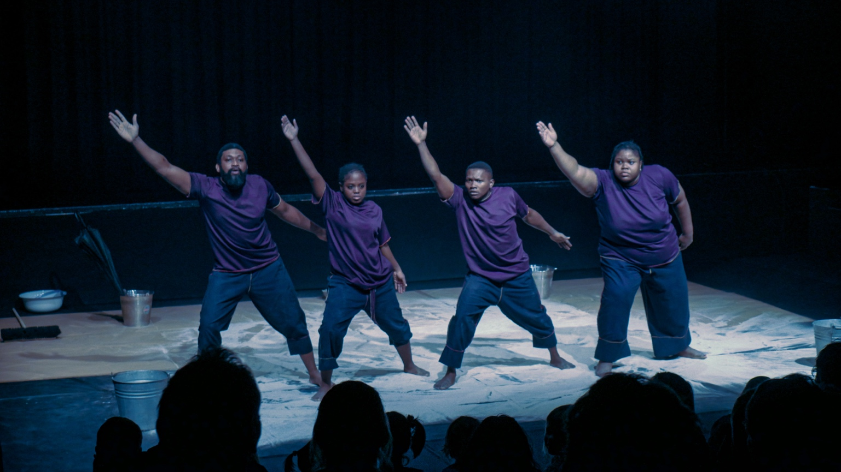

Sandscape
By
Kininso Concept

SHOW NOTES

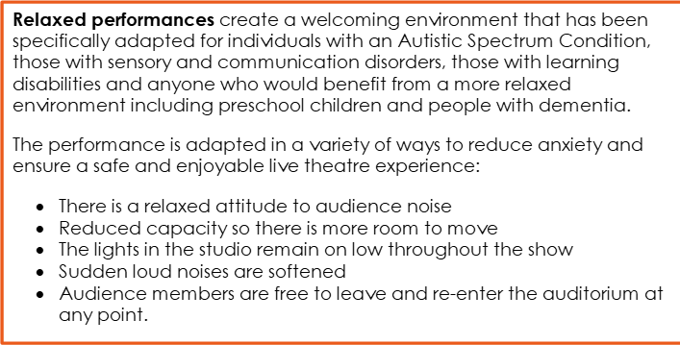

About the Show

- Sandscape is 40 minutes long and is suited for 4 years and over.
- The show explores sand Sand, how it feels when it runs through your hand, over umbrellas and into bucket.
- Sandscape is a silent theatrical piece that embraces the Beauty and Essence of Nature and evokes the visual, heart-rhythmic abilities that get you transfixed with the aid of Sand as its major tool.
- With the accompaniment of black plastic nylon, cups, umbrellas, and buckets. The piece immerses the audience into a world of playful experience.
- It is a relaxing and engaging piece of theatre that explores the texture, weight, and breath of sand on various materials. This piece offers an ever-changing view the sight of sand, swirling and creating shapes, prints, lines, games and landscape.

QUIETER SPACES

We have dedicated several spaces across our building for you if you need to take some time out of the performance. Simply ask an Usher to help you get where you’d like to be.

· There is a dedicated Quiet Room, away from noise and people, with somewhere to sit and fully take time.

WHEN THE SHOW BEGINS…AND WHAT TO EXPECT!

- The lights dim when the show is about to start
- Performers come on stage to begin the show
- People around you may quiet down in anticipation
- You will experience various sights and sounds during the show

- It is important that children or youngsters feel free in order to make the most of the experience.
- Sandscape is a silent performance.
- Sandscape aims to develop out of the NON-intervention of grown-ups / relatives in the free exploration of the audience.

The show will take place in…

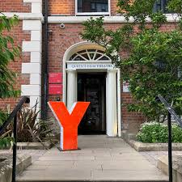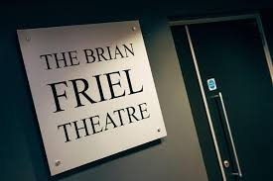

THE BRIAN FRIEL THEATRE

- Adjacent to the main university campus, the Brian Friel Theatre is located in the Queen's University Drama and Film Centre, Queen’s Film Theatre, at 20 University Square.
- One of the best equipped theatres in Belfast with a 120 seat studio theatre, rehearsal room, dressing rooms, green room and workshop.
- The theatre was officially opened in 2009 by Brian Friel, one of Ireland’s greatest, internationally acclaimed playwrights.

- HISTORY
The Brian Friel Centre for Theatre Research was opened by Brian Friel, one of Ireland’s greatest, internationally acclaimed playwrights, in 2009.
- The Friel Centre was acknowledged in the 2008 Research Assessment Exercise for producing world-leading and internationally excellent research in Irish theatre, as well as excellence in practice-as-research.
- Areas of staff research expertise include: modern Irish, European, American and British drama; Shakespeare in performance; Samuel Beckett; theatre and conflict and many many more.

WHAT INSIDE THE THEATRE LOOKS LIKE:

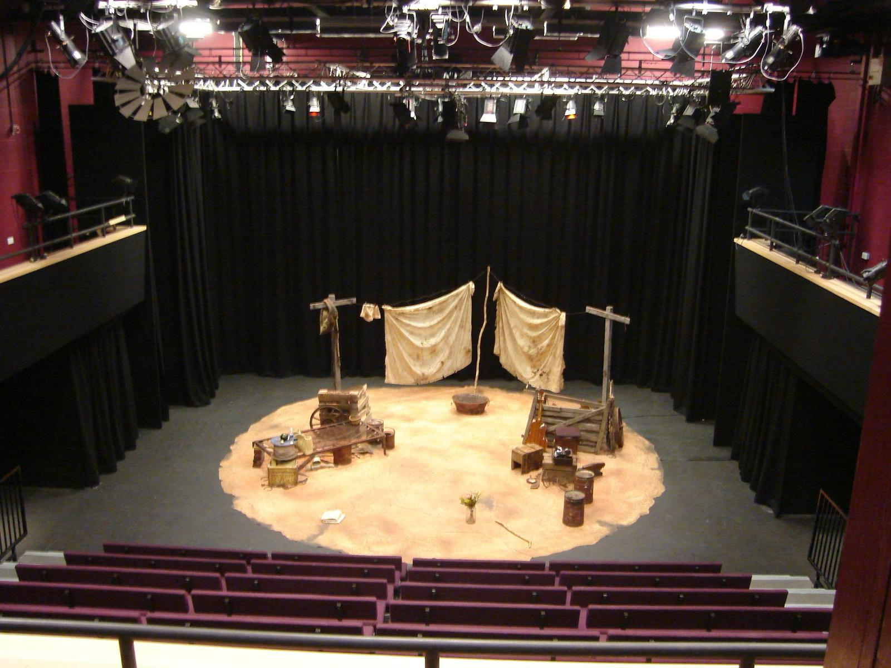

The foyer has sofas and tables so you can before the show. The bar serves soft drinks, popcorn and other snacks.

