Moonlight Dream

By
Maiden Voyage Dance

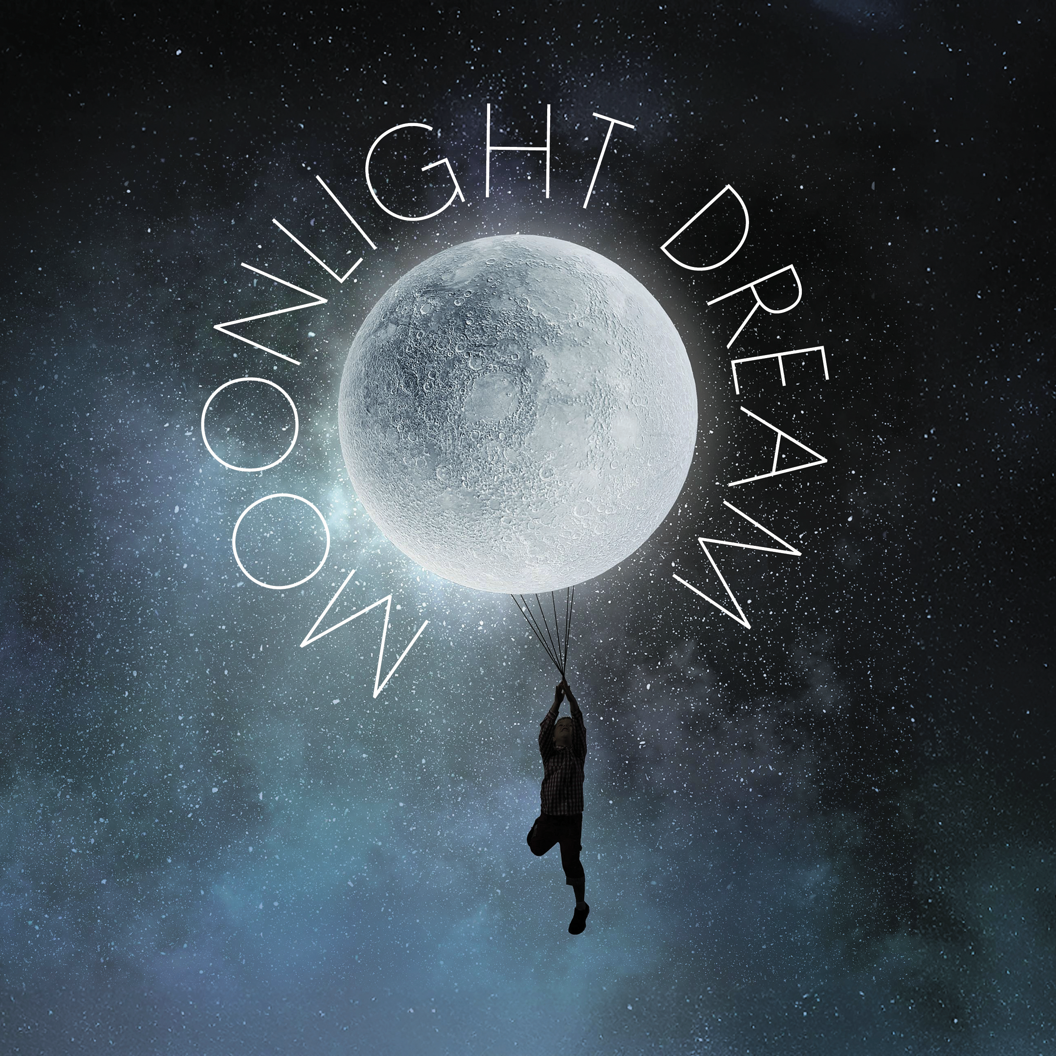

BELFAST CHILDREN’S FESTIVAL 2025
Teacher’s Resource

TABLE OF CONTENTS

About Us…………………………………….............................…page 3

How To Use This Resource……………..........................……page 4

Learning Intentions……………………...........................……..page 5

Specific Curriculum Links…………….........................………page 6

Summary of Moonlight Dream…………........................……page 8

Cast and Crew………………………............................………..page 9

Pre-Show Activities……………………..........................….….page 10

Preparing to Go!...............................…………………………..page 10

Meditation: Dream of a Quiet Place.....…..……………………page 11

Post-Show Activities…………………..........................………page 12

Thinking Back....................................…………………………page 12

Sensory Play.......................................………………..………page 14

About Us

Young at Art is one of Northern Ireland's leading children's arts not-for-profit companies and home of Belfast Children's Festival, which celebrated its 26th Anniversary in 2024. From its base in Belfast's city centre, Young at Art coordinates not only an international festival and a touring events agency, but also a wide variety of projects that encourage children and young people under 18 to enjoy the arts.

Young at Art believes passionately that every child should have the right to access exciting and original creative experiences, regardless of who they are or where they come from. The company believes that arts provision should be FOR children and young people, as well as BY children and young people.

‘Moonlight Dream’ Resource was compiled by Education & Engagement Co-ordinator Becca Wilson and Education & Engagement Assistant Katie Davies. This resource includes curriculum-based lessons and activities designed and was developed by Stranmillis University College student-teacher Thérèse Rainey.

To find out more about Young at Art, our performances and resources, please view our website www.youngatart.co.uk. Alternatively, contact our Education & Engagement Co-Ordinator on 028 9023 0660 or educationcoordinator@youngatart.co.uk

HOW TO USE THIS RESOURCE

This resource is intended to support teachers whose pupils are engaging with a performance of ‘Moonlight Dream’ during Belfast Children’s Festival 2025. It outlines pre- and post-performance activities that can be utilised to both prepare pupils for the performance and enable them to unpack and process the experience afterwards. While the pre-performance exercises will greatly aid the appreciation of the production, it is also extremely beneficial for pupils to be given the opportunity post-performance to explore the elements of the show and what they thought and felt about it. The performance can be used as a starting point for several exercises and lesson development long after the original experience.

The pre-performance activities outlined in this resource are designed to prepare your pupils for attending this performance. The activities can serve as warm-up games and exercises that engage the children in creative thinking, quick physical responses to suggestions, and experimenting with performance. It’s also helpful to introduce the vocabulary and skills which will maximise children’s engagement with the performance on the day and help to shape their critical responses. The suggested activities below include both active experimentation with performance, more reflective exercises based on teaching by questioning, and practical cross-curricular activities which explore themes within ‘Moonlight Dream’. The pre-performance activities can be reflected upon as a class and used to illustrate key concepts the children might encounter in a live theatre performance.

These concepts include:

- Themes of loneliness and negative emotion
- Exploring alternative ways to create music
- Exploring daily routine
- The use of artistic visual elements, e.g., light, shape, colour etc. to represent dreams and abstract ideas

If children are familiar with these concepts before experiencing a performance, there will be less of a 'shock factor' when they encounter them onstage. This leads to a deeper appreciation of the performance they will see.

Post-performance activities aim to elicit responses from the pupils by encouraging critical appraisal of the performance they have seen as a class. The activities allow the students to explore how they felt about the performance, what they remember, and what they thought of it. They also act as tools that can be used to encourage the children to express their own ideas and emotions in a safe, imaginative and creative way. Both sets of activities are intended to be adapted by teachers as they see fit to suit their own and their classes’ needs and interests. The cross-curriculum potential is endless!

Learning Intentions

Pupils will be encouraged to:

- Work on their talking and listening skills
- Work with physical materials to create art
- Perform and play musical rhythms
- Develop their emotional awareness
- Work on time management

CURRICULUM LINKS

Experiencing different forms of live theatre and performance provide the opportunity for different modes of learning within the curriculum. These experiences include the independent experience as an audience member, cooperative learning through group discussion and group play, and practical activities pre- and post-performance.
Specific Curriculum Links which can be made to ‘Moonlight Dream’ at varying levels include:

KS1 & 2
Art and Design
- Use thoughts and ideas as the basis for visual work
- Investigate colour and texture
- Work with the visual elements to explore and create visual outcomes, talk about and comment on what they produce
- View examples of art
- Use what they have seen as a stimulus or starting point for Individual ideas and personal interpretations
- appreciate how to use mark making materials

Music
- Work creatively with sound
- Talk about the sounds they hear
- Perform with simple instruments
- Listen and respond to own and other’s music

Language and Literacy
- Talking about experiences, pictures and stories
- Use of social language
- Observing modelled behaviours
- Talking about their work, play and things they have made
- Recalling
- Sequencing
- Asking and answering questions
- Describing
- Explaining
- Sharing their thoughts, feelings and ideas with different audiences
- Taking part/contributing to group oral language activities
- Listening and responding to adults and peers

Personal Development and Mutual Understanding
- Encouraged to develop a positive attitude to learning
- Expressing how they feel
- Themselves and their personal attributes
- Recognising their own and others’ feelings and emotions
- Recognising what they can do
- Beginning to recognise how they feel
- Developing ways of expressing how they feel

SUMMARY OF MOONLIGHT DREAM

Duration: 30 minutes
Age: 0-3

Moonlight Dream is a new dance theatre production created for babies aged 0-3 years and their caregivers. This heartwarming show draws inspiration from the comforting bedtime rituals and soothing stories to explore the gentle transition into sleep and the journey into the world of dreams.
This immersive sensory-rich journey takes audiences on a voyage to the moon and beyond, wrapped in the comforting power of lullabies and the calm of twilight.
The story follows a young child who embarks on an imaginative adventure with two delightful companions: a kind bear and a playful fox. Together, they navigate the mysteries of the night sky, discovering shimmering stars, moonlit rivers, and magical oceans. The moon becomes a gentle guide for the young traveller until the long-anticipated sleep is finally achieved.

This is a relaxed performance, and older children are welcome as the piece is suitable for all.

CAST AND CREW

Choreographer......................................Georgia Tegou

Composer and Live Music........................Ursula Burns

Dancers..............................................Sandy Cuthbert
Janie Doherty
Andrea Madore

Set and Lighting Design..........................Ciaran Bagnall

Costume Design.........................................Una Hickey

Pre-Show Activities

To prepare children for viewing the show

Activity 1: Preparing to Go!

Set up: Move all the desks, pupils sit in a circle on the floor

Specific curriculum links: The Arts; Language Development; Early Mathematical Experiences; Personal, Social and Emotional Development; The World Around Us.

How to play:
- Generate a discussion with the children about shows. Have they ever been to any or seen any on tv before? Talk about shows aimed at children they might have attended like the pantomime or school plays.

- What kinds of things did the characters do? What can they remember from their experiences?

- Next, ask the children to think about their emotions regarding the upcoming performance. What are their concerns/ questions? How can these be addressed before they go? Layout clear expectations both for their own behaviour and what they are likely to experience. This is useful to ensure you as the teacher have prepared for any scenario

- Get them excited! What are they most looking forward to?

Skill Outcomes
Increased ability to:
- recall events and details
- critical Thinking
- offer and express independent opinions
- think creatively and imaginatively
- empathise
- concentrate, listen and observe
- respect each other’s opinions

Activity 2: Meditation: Dream of a quiet place

Set up: Usual classroom setting

Specific curriculum links: The Arts; Language Development; Early Mathematical Experiences; Personal, Social and Emotional Development; The World Around Us.

How to play:
- Ask the children to close their eyes, relax their shoulders and take a deep breath.
- Ask them to think about a place where they feel safe or to create a calm place they can go to in their minds.
- Ask them to think what is it about this place that makes them feel good/ how could they find this in their everyday lives.

Skill Outcomes
Increased ability to:
- recall events and details
- critical Thinking
- offer and express independent opinions
- think creatively and imaginatively
- empathise
- concentrate, listen and observe

POST-SHOW ACTIVITIES
To unpack the experience of the show

Activity 1: THINKING BACK

Set up: Usual classroom setting

Specific curriculum links: The Arts; Language Development; Early Mathematical Experiences; Personal, Social and Emotional Development; The World Around Us.

How to play
- Generate a discussion with the children about the show. What do they remember about it? What were the most important/funniest/ most enjoyable parts of the show? When did the lights/music change? What effect did this have? Were there any sound effects? Why? What effect did this have?

- What kinds of things did the characters do? What sounds and actions can they remember from the film? How did the characters move? How did they use non-verbal communication?

- The teacher can then ask each child to talk about their favourite moment and further explore the pupils’ positive memories of the film: Why did you like this? What made it funny? Were there any other parts that haven’t been mentioned that you liked? The responses can be recorded for evaluation/feedback purposes.

- Next, ask the children to think about the emotions from the performance. When were there happy/sad moments etc.? Did the music and lighting affect the emotions in the performance? What did they think about the way the actors moved? What can they remember about the set, objects, costumes?

- This leads to talking about the relationship between the actors and their objects. What kind of relationships do they have? Can they remember what the actors did with different objects?

- The exact same process is then repeated with the question: What was your least favourite part of the show?

Skill Outcomes
Increased ability to:
- recall events and details
- offer and express independent opinions
- tell and create stories
- think creatively and imaginatively
- empathise
- concentrate, listen and observe
- respect each other’s opinions
- identify elements from the show such as shapes, objects, characters.

Building on
- This activity can be built upon by each child acting out their favourite part of the show. The rest of the group can see if they can recognise the part of the performance. Can they remember what the music was like during each part? Draw attention to the non-verbal elements of the show. Did the performance tell a story without talking? What do the children think about non-verbal communication?

- Next ask the children if they were satisfied with the ending of the show? Why? Why not? Can they suggest an alternative ending? These can be developed into mini choreographies, mini dramas or illustrations.

Activity 2: Sensory Play

Set up: Bring the tables together to make a circle. Clear the desks and cover with art tablecloths.

Resources: Paper, colouring utensils, art supplies/craft material, bubbles, puzzles and assortment of books.

Specific curriculum links: The Arts; Language Development; Early Mathematical Experiences; Personal, Social and Emotional Development; The World Around Us.

How to play:
- Hand out play dough, bottles of bubbles, puzzles, colouring pencils, paper and books.

- Set up different sensory stations for the kids to enjoy and relax.

- Play calming music in the background to create a calming ambience

Skill Outcomes
Increased ability to:
- Practice mindfulness
- Independently play
- Observe
- Think creatively and imaginatively
- Tell and create stories

