

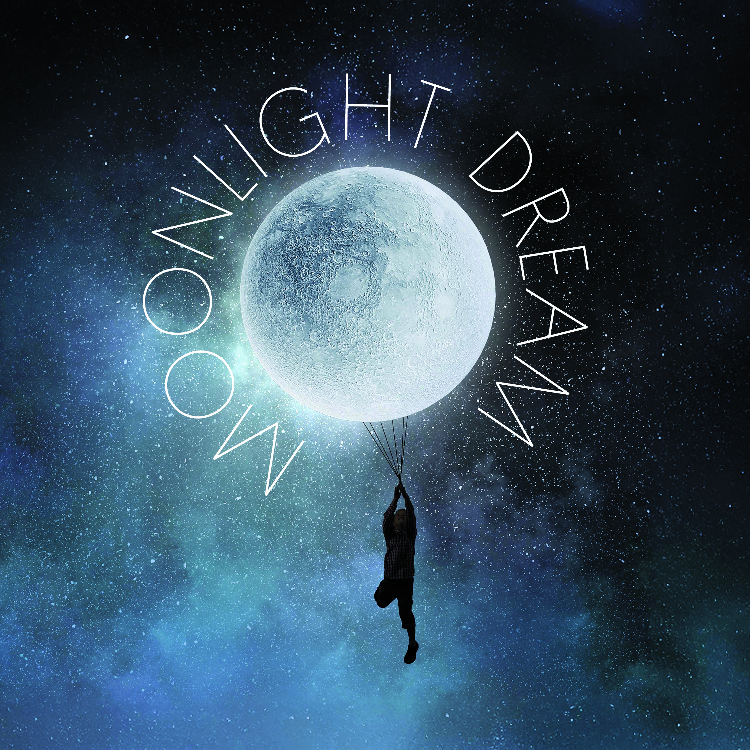

MOONLIGHT DREAM
BY
Maiden Voyage

SHOW NOTES

Relaxed Performances create a welcoming environment that has been specifically adapted for individuals with an Autistic Spectrum Condition, those with sensory and communication disorders, those with learning disabilities and anyone who would benefit from a more relaxed environment including preschool children and people with dementia.

The performance is adapted in a variety of ways to reduce anxiety and ensure a safe and enjoyable live theatre experience:

- There is a relaxed attitude to audience noise.
- Reduced capacity so there is more room to move.
- The lights in the studio remain on low throughout the show.
- Sudden loud noises are softened.

Audience members are free to leave and re-enter the auditorium at any point.

SYNOPSIS

- Moonlight Dream is 30 minutes long.
- It is suited to 0-3 year olds.
- A Baby’s Cosmic Odyssey.
- It is performed in the Crescent Arts Centre.
- It draws inspiration from the comforting bedtime rituals and soothing evening stories that little ones experience.
- It is about the gentle transition into sleep and the journey into the world of dreams and is sensory rich.

- If at any time you would like to take a break you can take a step away from the performance area or leave the theatre and come back whenever you’re ready. An usher will be there to help you.
- The Ushers are there to help you. They can show you where the toilets are. Ushers are good people to go to if you feel worried about anything in the show. You can speak to them before, during or after the performance.

QUIETER SPACES

- We have dedicated several spaces across our building for you if you need to take some time out of the performance. You can ask an Usher to help you get to where you would prefer to be.
- There is some space immediately outside of the Weston Studio where you can take a breather if you need to.
- There is also a dedicated Quiet Room, away from noise and people, with somewhere to sit and fully take time out in The Foyle Room on Level 1.



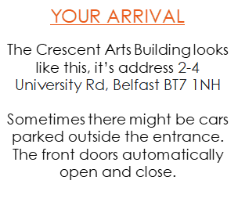
INSIDE: GROUND FLOOR

ENTRANCE
There will be Crescent staff at the entrance (Box Office) and in the Kiosk and the Cafe/Bar, so if you need some help or are not sure of where to go, they will be happy to help. The Crescent Staff are friendly and they will answer any question you have for them.

When you are waiting, you can have something to eat or drink. The auditorium might not be open yet so you might have to wait a little while until you can go in to take your seat.
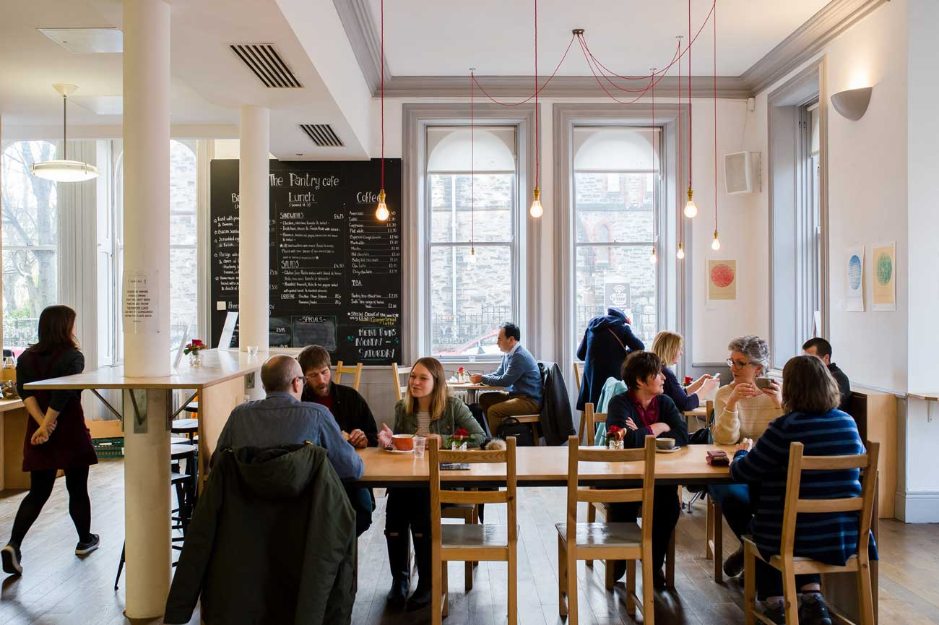

WHEN THE SHOW BEGINS…AND WHAT TO EXPECT!

- The lights dim when the show is about to start
- Performers come on stage to begin the show
- People around you may quiet down in anticipation
- You will experience various sights and sounds during the show
- It has a dreamy atmosphere, gentle sounds and soft lunar landscapes.
- The moon becomes a gentle guide for the young traveller until the long-anticipated sleep is finally achieved.
- A wonderful opportunity for parents and caregivers to relax with their little ones and let the dreamy atmosphere of gentle sounds, soft lunar landscapes, and twinkling starlight carry them on a cosmic adventure.
- This is a relaxed performance and older children are welcome as the piece is suitable for all.



