Fall and Float
By
Monica Munoz Dance

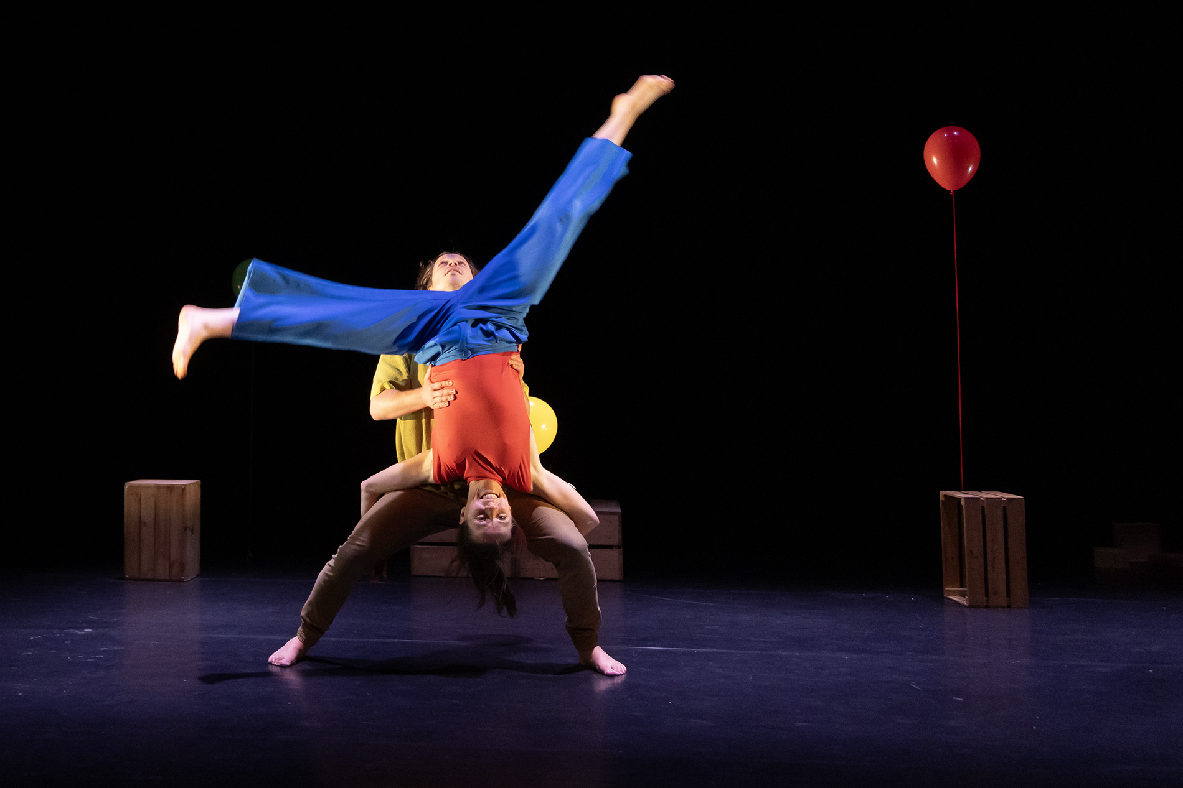

BELFAST CHILDREN’S FESTIVAL 2025
Teacher’s Resource

TABLE OF CONTENTS

About Young at Art ………………………….......................……………page 3

How to use this Resource ……………………....................………….page 4

Learning Intentions …………………………….....................………….page 5

Curriculum Links ………………………………....................…………..page 6

Summary of Fall and Float……………………....................….........page 8

Cast and Crew …………………………………......................………....page 9

Pre-Show Activities …………………………………....................…….page 10

Preparing to Go! ………..………...........................................…...page 10

Balloon Running ……….……………………………...........................page 11

Making Balloon Faces…………………………….....................……..page 12

Post-Show Activities ……………………………....................……….page 14

Thinking Back………………...............................................……..page 14

Sound Experiments………………….………….....................………..page 15

Recreating the Balloon Hoods…...………………..…............………page 16
About Us

Young at Art is one of Northern Ireland's leading children's arts not-for-profit companies and home of Belfast Children's Festival, which celebrated its 26th Anniversary in 2024. From its base in Belfast's City Centre, Young at Art coordinates not only an international festival and a touring events agency, but also a wide variety of projects that encourage children and young people under 18 to enjoy the arts.

Young at Art believes passionately that every child should have the right to access exciting and original creative experiences, regardless of who they are or where they come from. The company believes that arts provision should be FOR children and young people, as well as BY children and young people.

‘Fall and Float’ Resource was compiled by Education & Engagement Co-ordinator Becca Wilson and Education & Engagement Assistant Katie Davies. This resource includes curriculum-based lessons and activities designed and was developed by Stranmillis University College student-teacher Thérèse Rainey.

To find out more about Young at Art, our performances and resources, please view our website www.youngatart.co.uk. Alternatively, contact our Education & Engagement Co-Ordinator on 028 9023 0660 or educationcoordinator@youngatart.co.uk

HOW TO USE THIS RESOURCE

This resource is intended to support teachers whose pupils are engaging with a performance of ‘Fall and Float’ during Belfast Children’s Festival 2025. It outlines pre- and post-performance activities that can be utilised to both prepare pupils for the performance and enable them to unpack and process the experience afterwards. While the pre-performance exercises will greatly aid the appreciation of the production, it is also extremely beneficial for pupils to be given the opportunity post-performance to explore the elements of the show and what they thought and felt about it. The performance can be used as a starting point for a number of exercises and lesson development long after the original experience.

The pre-performance activities outlined in this resource are designed to prepare your pupils for attending this performance. The activities can serve as warm-up games and exercises that engage the children in creative thinking, quick physical responses to suggestions, and experimenting with performance. It’s also helpful to introduce the vocabulary and skills which will maximise children’s engagement with the performance on the day and help to shape their critical responses. The suggested activities below include both active experimentation with performance, more reflective exercises based on teaching by questioning, and practical cross-curricular activities which explore themes within ‘Fall and Float’. The pre-performance activities can be reflected upon as a class and used to illustrate key concepts the children might encounter in a live theatre performance.

These concepts include:

- Themes of loneliness and negative emotion
- Exploring alternative ways to create music
- Exploring daily routine
- The use of artistic visual elements, e.g., light, shape, colour etc. to represent dreams and abstract ideas
If children are familiar with these concepts before experiencing a performance, there will be less of a 'shock factor' when they encounter them onstage. This leads to a deeper appreciation of the performance they will see.

Post-performance activities aim to elicit responses from the pupils by encouraging critical appraisal of the performance they have seen as a class. The activities allow the students to explore how they felt about the performance, what they remember, and what they thought of it. They also act as tools that can be used to encourage the children to express their own ideas and emotions in a safe, imaginative and creative way. Both sets of activities are intended to be adapted by teachers as they see fit to suit their own and their classes’ needs and interests. The cross-curriculum potential is endless!

Learning Intentions
Pupils will be encouraged to:

- Work on their talking and listening skills
- Work with physical materials to create art
- Perform and play musical rhythms
- Develop their emotional awareness
- Work on time management

CURRICULUM LINKS

Experiencing different forms of live theatre and performance provide the opportunity for different modes of learning within the curriculum. These experiences include the independent experience as an audience member, cooperative learning through group discussion and group play, and practical activities pre- and post-performance.

Specific Curriculum Links which can be made to ‘Fall and Float’ at varying levels include:

KS1 & 2
Art and Design
- Use thoughts and ideas as the basis for visual work
- Investigate colour and texture
- Work with the visual elements to explore and create visual outcomes, talk about and comment on what they produce
- View examples of art
- Use what they have seen as a stimulus or starting point for Individual ideas and personal interpretations
- appreciate how to use mark making materials

Music
- Work creatively with sound
- Talk about the sounds they hear
- Perform with simple instruments
- Listen and respond to own and other’s music

Language and Literacy
- Talking about experiences, pictures and stories
- Use of social language
- Observing modelled behaviours
- Talking about their work, play and things they have made
- Recalling
- Sequencing
- Asking and answering questions
- Describing
- Explaining
- Sharing their thoughts, feelings and ideas with different audiences
- Taking part/contributing to group oral language activities
- Listening and responding to adults and peers

Personal Development and Mutual Understanding
- Encouraged to develop a positive attitude to learning
- Expressing how they feel
- Themselves and their personal attributes
- Recognising their own and others’ feelings and emotions
- Recognising what they can do
- Beginning to recognise how they feel
- Developing ways of expressing how they feel

SUMMARY OF
FALL and FLOAT

Duration: 40 mins
Age: 4+

With playful energy, impressive acrobatics, comic timing and a joyful soundscape, two dancers create a magical world through the clever manipulation of simple balloons.
Their imagination seems to know no bounds- resulting in a hypnotic, funny and uplifting performance full of falling, throwing, catching, stumbling, floating... and sometimes maybe even a little bit of flying...

Cast and Crew

Director…………………………………..……..Monica Munoz

Cast………………..……….Martijn Joling and Amy Pender

Music and Sound Design………….……..Denis Clohessy

Set & Costume Design………….…..Laura Fajardo Castro

Lighting Design………………….….Sebastian Pizarro Tour

Producer………………………………………..Michelle Cahill

Photo Credits………………..…………….Maurice Gunning

Presented By……………………..….Monica Munoz Dance

Assistant Producer……………………..……Sophie Coote

PRE-SHOW ACTIVITIES
To prepare children for viewing the show

Activity 1: Preparing to Go!

Set up: Move all the desks, pupils sit in a circle on the floor

Specific curriculum links: The Arts; Language Development; Early Mathematical Experiences; Personal, Social and Emotional Development; The World Around Us.

How to play:
- Generate a discussion with the children about shows. Have they ever been to any or seen any on tv before? Talk about shows aimed at children they might have attended like the pantomime or school plays.

- What kinds of things did the characters do? What can they remember from their experiences?

- Next, ask the children to think about their emotions regarding the upcoming performance. What are their concerns/ questions? How can these be addressed before they go? Layout clear expectations both for their own behaviour and what they are likely to experience. This is useful to ensure you as the teacher have prepared for any scenario

- Get them excited! What are they most looking forward to?

Skill Outcomes:
Increased ability to:
- recall events and details
- critical Thinking
- offer and express independent opinions
- think creatively and imaginatively
- empathise
- concentrate, listen and observe
- respect each other’s opinions

Activity 2: Balloon Running

Set up: Give a different coloured balloon to each child at their desk.
Move desks and make space to walk around the classroom.

Resources: A range of different coloured balloons and some string

Specific Curriculum Links: The Arts; Language Development; Early Mathematical Experiences; Personal, Social and Emotional Development; The World Around Us.

How to Play:
- Ask the children to blow up their balloons and attach strings to the bottom. Help them if needed.

- Make sure to give a few of each colour out.

- Ask the children to stand in a circle. Call out a colour and the children with that coloured balloon must run to find a new space in the circle.

- Continue this until all children have changed their location within the circle.

Skill Outcomes
Increased ability to:
- Observe and respond quickly
- concentrate, listen and observe
- Be creative
- Experiment with different materials
- Teamwork with other children

Activity 3: Making balloon faces

Set up: Use the same balloons as the first activity. Work at desks and then move out to the playground.

Resources: Different coloured markers, paints, brushes.

Specific Curriculum Links: The Arts; Language Development; Early Mathematical Experiences; Personal, Social and Emotional Development; The World Around Us.

How to Play:
- Using the same balloons from the first activity, ask the children to draw any type of face on their balloons. They can also use paint and make a pattern or design.
- Let them create a personality, a character, out of the balloon.
- Take the children outside into the playground with their balloon friends. Let them experience the elements of the outdoors with their balloons.
- Encourage them to use their imagination and go on a journey.
- The activity can become socialised by the children walking around the playground to their peers, then comparing their balloons.

Skill Outcomes:
Increased ability to:
- Use their imagination
- tell and create stories
- think creatively and imaginatively
- 3-D construction and illustration
- Engage their imagination through improvisation

Post-Show Activities

Activity 1: Thinking Back

Set up: Usual classroom setting

Specific Curriculum Links: The Arts; Language Development; Early Mathematical Experiences; Personal, Social and Emotional Development; The World Around Us.

How to Play:
- Generate a discussion with the children about the show. What do they remember about it? What were the most important/funniest/ most enjoyable parts of the show? When did the lights/music change? What effect did this have? Were there any sound effects? Why? What effect did this have?
- What kinds of things did the characters do? What sounds and actions can they remember from the film? How did the characters move? How did they use non-verbal communication?
- The teacher can then ask each child to talk about their favourite moment and further explore the pupils’ positive memories of the film: Why did you like this? What made it funny? Were there any other parts that haven’t been mentioned that you liked? The responses can be recorded for evaluation/feedback purposes.
- Next, ask the children to think about the emotions from the performance. When were there happy/sad moments etc.? Did the music and lighting affect the emotions in the performance? What did they think about the way the actors moved? What can they remember about the set, objects, costumes?
- This leads to talking about the relationship between the actors and their objects. What kind of relationships do they have? Can they remember what the actors did with different objects?
- The exact same process is then repeated with the question: What was your least favourite part of the show?

Skill Outcomes
Increased ability to:
- Recall events and details
- Offer and express independent opinions
- Tell and create stories
- Think creatively and imaginatively
- Empathise
- Concentrate, listen and observe

Activity 2: Sound Experiments

Set up: Move desks so there is space on the floor for the children to sit in a circle.

Resources: Different shaped balloons. Beads, rice.

Specific Curriculum Links: The Arts; Language Development; Early Mathematical Experiences; Personal, Social and Emotional Development; The World Around Us.

How to Play:
- Fill some of the balloons with either dry rice or arts and craft beads.
- Blow up the balloons.
- Pass around the balloons and experiment with the sounds the balloons can make.
- Once they are passed around, they must guess which balloon has which filling.

Skill Outcomes
Increased ability to:
- Decipher different noises and sounds
- Use their creativity
- Respect others opinions
- Observe and listen

Activity 3: Recreating the Balloon Heads

Set up: clear space

Resources: Jackets, balloons.

Specific Curriculum Links: The Arts; Language Development; Early Mathematical Experiences; Personal, Social and Emotional Development; The World Around Us.

How to Play:
- Ask the children did they enjoy the part of the show with the ‘balloon heads’. what did they like/not like about it? How did they feel when they saw it?
- Re-use the balloons that the children designed previously.
- Collect their coats or jackets and ask them to put them on.
- Help them to put their jackets on and put their balloons in their hoods.
- After all the giggles, get the class to think about a character for their balloon heads. Try funny voices and movements to enhance the characters they have created.

To develop: get into pairs and allow one to be the voice while the other acts out the dialogue with their balloon head. Make up a story or tell a well-known story. This develops listening and teamwork skills.

Skill Outcomes
Increased ability to:
- Relax and have fun with their classmates
- Take things less seriously
- Control body movements
- Explore a range of movement skills
- Use imagination creatively

This resource is the copyright of Young at Art 2025 and should not be reproduced or distributed to any third party. It is solely for use in educational settings in conjunction with the performance of Fall and Float.

