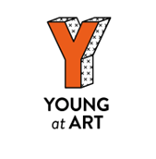

Der Lauf

By
Les Vélocimanies Associés

BELFAST CHILDREN’S FESTIVAL 2025

Teacher’s Resource

TABLE OF CONTENTS

About Young at Art ………………………………………page 3

How to use this Resource ………………………...….page 4

Learning Intentions ………………………….......……page 5

Curriculum Links …………………………...…………..page 6

Summary of Der Lauf …………............................page 8

Cast and Crew ………………………….......………....page 9

Pre-Show Activities …………………………...……….page 10

Preparing to Go! ……..……........................……...page 10

Blindfolded Journeys…….………….....…….……….page 11

Creative Writing.......………………………….………..page 12

Post-Show Activities …………...……...….………….page 13

Thinking Back………………..........................……..page 13

Science Experiment ...……..……….…...…..………..page 15

Go with the Flow......…...…………….…..…....………page 16

About Us

Young at Art is one of Northern Ireland's leading children's arts not-for-profit companies and home of Belfast Children's Festival, which celebrated its 26th Anniversary in 2024. From its base in Belfast's City Centre, Young at Art coordinates not only an international festival and a touring events agency, but also a wide variety of projects that encourage children and young people under 18 to enjoy the arts.

Young at Art believes passionately that every child should have the right to access exciting and original creative experiences, regardless of who they are or where they come from. The company believes that arts provision should be FOR children and young people, as well as BY children and young people.

‘Der Lauf’ Resource was compiled by Education & Engagement Co-ordinator Becca Wilson and Education & Engagement Assistant Katie Davies. This resource includes curriculum-based lessons and activities designed and was developed by Stranmillis University College student-teacher Thérèse Rainey.

To find out more about Young at Art, our performances and resources, please view our website www.youngatart.co.uk. Alternatively, contact our Education & Engagement Co-Ordinator on 028 9023 0660 or educationcoordinator@youngatart.co.uk

HOW TO USE THIS RESOURCE

This resource is intended to support teachers whose pupils are engaging with a performance of ‘Der Lauf’ during Belfast Children’s Festival 2025. It outlines pre- and post- performance activities that can be utilised to both prepare pupils for the performance and enable them to unpack and process the experience afterwards. While the pre-performance exercises will greatly aid the appreciation of the production, it is also extremely beneficial for pupils to be given the opportunity post-performance to explore the elements of the show and what they thought and felt about it. The performance can be used as a starting point for a number of exercises and lesson development long after the original experience.

The pre-performance activities outlined in this resource are designed to prepare your pupils for attending this performance. The activities can serve as warm-up games and exercises that engage the children in creative thinking, quick physical responses to suggestions, and experimenting with performance. It’s also helpful to introduce the vocabulary and skills which will maximise children’s engagement with the performance on the day and help to shape their critical responses. The suggested activities below include both active experimentation with performance, more reflective exercises based on teaching by questioning, and practical cross-curricular activities which explore themes within ‘Der Lauf’. The pre-performance activities can be reflected upon as a class and used to illustrate key concepts the children might encounter in a live theatre performance.

These concepts include:

- Themes of loneliness and negative emotion
- Exploring alternative ways to create music
- Exploring daily routine
- The use of artistic visual elements, e.g., light, shape, colour etc. to represent dreams and abstract ideas

If children are familiar with these concepts before experiencing a performance, there will be less of a 'shock factor' when they encounter them onstage. This leads to a deeper appreciation of the performance they will see.

Post-performance activities aim to elicit responses from the pupils by encouraging critical appraisal of the performance they have seen as a class. The activities allow the students to explore how they felt about the performance, what they remember, and what they thought of it. They also act as tools that can be used to encourage the children to express their own ideas and emotions in a safe, imaginative and creative way. Both sets of activities are intended to be adapted by teachers as they see fit to suit their own and their classes’ needs and interests. The cross-curriculum potential is endless!

Learning Intentions

Pupils will be encouraged to:
- Work on their talking and listening skills
- Work with physical materials to create art
- Perform and play musical rhythms
- Develop their emotional awareness and expression
- Work on time management

CURRICULUM LINKS

Experiencing different forms of live theatre and performance provide the opportunity for different modes of learning within the curriculum. These experiences include the independent experience as an audience member, cooperative learning through group discussion and group play, and practical activities pre- and post-performance.

Specific Curriculum Links which can be made to ‘Der Lauf’ at varying levels include:

KS1 & 2
Art and Design
- Use thoughts and ideas as the basis for visual work
- Investigate colour and texture
- Work with the visual elements to explore and create visual outcomes, talk about and comment on what they produce
- View examples of art
- Use what they have seen as a stimulus or starting point for Individual ideas and personal interpretations
- appreciate how to use mark making materials

Music
- Work creatively with sound
- Talk about the sounds they hear
- Perform with simple instruments
- Listen and respond to own and other’s music

Language and Literacy
- Talking about experiences, pictures and stories
- Use of social language
- Observing modelled behaviours
- Talking about their work, play and things they have made
- Recalling
- Sequencing
- Asking and answering questions
- Describing
- Explaining
- Sharing their thoughts, feelings and ideas with different audiences
- Taking part/contributing to group oral language activities
- Listening and responding to adults and peers

Personal Development and Mutual Understanding
- Encouraged to develop a positive attitude to learning
- Expressing how they feel
- Themselves and their personal attributes
- Recognising their own and others’ feelings and emotions
- Recognising what they can do
- Beginning to recognise how they feel
- Developing ways of expressing how they feel

SUMMARY OF DER LAUF

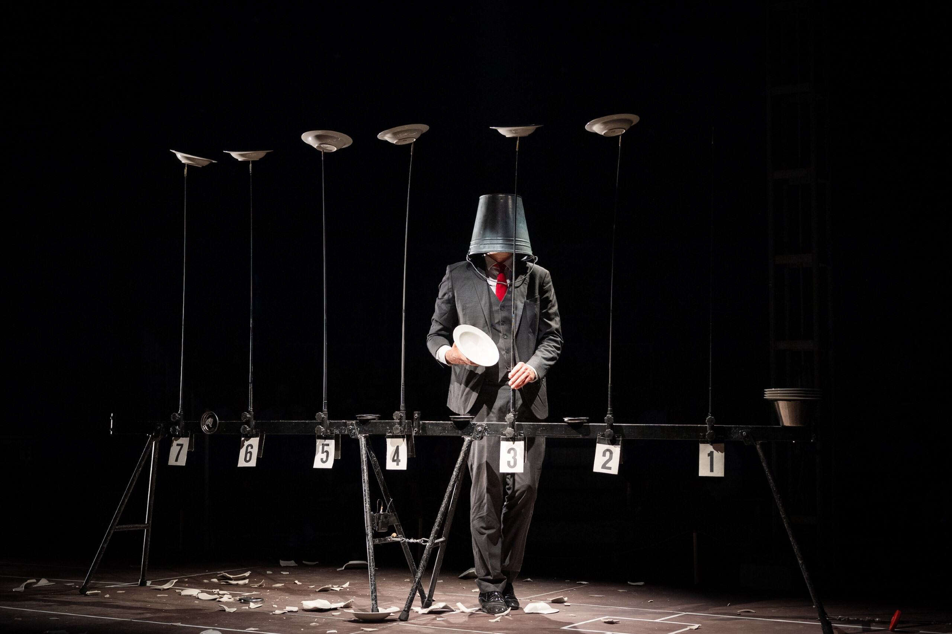
Duration: 55 minutes
Age: 10+
In a dark and intimate atmosphere, halfway between David Lynch and Intervilles, five short pieces in the form of absurd games. In this surreal world of Der Lauf, nothing is quite as it seems. Two circus performers compete in a series of bizarre challenges as they juggle blindly, spin plates wildly and stack glasses wearing enormous boxing gloves. As the stacks of glasses rise, so do the stakes. Will you, their only guide, help lead them to safety or towards further peril?
With the support of la Fédération Wallonie Bruxelles, la DRAC, la Région Hauts-de-France, le Département du Pas-de-Calais, la Communauté d'Agglomération Hénin-Carvin, la Ville de Carvin et la Ville de Lille
Cast and Crew

Creation and play…………………Guy Waerenburgh, Edouard Cuvelier (or Morgan Cosquer, or Stan Vangheluwe) and Julien Lanaud (or Juliette Delfosse or Paul Roussier or David Maillard)

Lighting Design………………………Julien Lanaud

Production Manager………………. Anne-Agathe Prin

Artistic Director…………………..Guy Waerenburgh

PRE-SHOW ACTIVITIES
To prepare children for viewing the show

Activity 1: Preparing to Go!

Set up: Move all the desks, pupils sit in a circle on the floor

Specific curriculum links: The Arts; Language Development; Early Mathematical Experiences; Personal, Social and Emotional Development; The World Around Us.

How to play:
- Generate a discussion with the children about shows. Have they ever been to any or seen any on tv before? Talk about shows aimed at children they might have attended like the pantomime or school plays.

- What kinds of things did the characters do? What can they remember from their experiences?

- Next, ask the children to think about their emotions regarding the upcoming performance. What are their concerns/ questions? How can these be addressed before they go? Layout clear expectations both for their own behaviour and what they are likely to experience. This is useful to ensure you as the teacher have prepared for any scenario

- Get them excited! What are they most looking forward to?

Skill Outcomes:
Increased ability to:
- recall events and details
- critical Thinking
- offer and express independent opinions
- think creatively and imaginatively
- empathise
- concentrate, listen and observe
- respect each other’s opinions

Activity 2: Blindfolded Journeys

Set up: Clear space in the centre of the classroom.

Resources: Piece of fabric or tie to tie around eyes. Props to place on the ground to create an obstacle course.

Specific curriculum links: The Arts; Language Development; Early Mathematical Experiences; Personal, Social and Emotional Development; The World Around Us.

How to play:
- Ask the class who wants to volunteer to be blindfolded.
- Help the rest of the children to set up an obstacle course.
- The blindfolded child must make it from one side of the classroom to the others
- As a team, everyone must advise the blindfolded child over and around the different objects on the ground in order to reach the other side.
- Is the end location where the child thought they would be?

Skill Outcomes:
Increased ability to:
- Listen to others
- Focus on and persist with tasks
- Be creative
- Experiment with different materials
- Think creatively and imaginatively

Building on
In groups the children can continue this game, letting others have a go with the items they have made. Every child may have taken a different route and had a different experience.

Activity 3: Creative Writing

Set up: Split the class into groups

Specific curriculum links: The Arts; Language Development; Social and Emotional Development;

How to play:
- Ask the children to think as a group about a potential journey someone could go on.
- Let their imagination run wild.
- What does their character come across on its way? Who do they meet? Where does they start and where do they end up? Is it where they thought?

Skill Outcomes
Increased ability to:
- Listen to each other
- Reflect and analyse
- Be creative
- Focus on and persist with tasks

POST-SHOW ACTIVITIES
To unpack the experience of the show

Activity 1: THINKING BACK

Set Up: Usual classroom setting

Specific curriculum links: The Arts; Language Development; Early Mathematical Experiences; Personal, Social and Emotional Development; The World Around Us.

How to play
- Generate a discussion with the children about the show. What do they remember about it? What were the most important/funniest/ most enjoyable parts of the show? When did the lights/music change? What effect did this have? Were there any sound effects? Why? What effect did this have?

- What kinds of things did the characters do? What sounds and actions can they remember from the show? How did the characters move? How did they use non-verbal communication?

- The teacher can then ask each child to talk about their favourite moment and further explore the pupils’ positive memories of the performance: Why did you like this? What made it funny? Were there any other parts that haven’t been mentioned that you liked? The responses can be recorded for evaluation/feedback purposes.

- Next, ask the children to think about the emotions from the performance. When were there happy/sad moments etc.? Did the music and lighting affect the emotions in the performance? What did they think about the way the actors moved? What can they remember about the set, objects, costumes?

- This leads to talking about the relationship between the actors and their objects. What kind of relationships do they have? Can they remember what the actors did with different objects?

- The exact same process is then repeated with the question: What was your least favourite part of the show?

Skill Outcomes
Increased ability to:
- recall events and details
- offer and express independent opinions
- tell and create stories
- think creatively and imaginatively
- empathise
- concentrate, listen and observe
- respect each other’s opinions
- identify elements from the show such as shapes, objects, characters.

Building on
- This activity can be built upon by each child acting out their favourite part of the show. The rest of the group can see if they can recognise the part of the performance. Can they remember what the music was like during each part? Draw attention to the non-verbal elements of the show. Did the performance tell a story without talking? What do the children think about non-verbal communication?

- Next ask the children if they were satisfied with the ending of the show? Why? Why not? Can they suggest an alternative ending? These can be developed into mini choreographies, mini dramas or illustrations.

Activity 2: Science Experiment

Set up: In the playground

Resources: Materials from the classroom and art supplies.

Specific Curriculum Links: The Arts; Language Development; Early Mathematical Experiences; Personal, Social and Emotional Development; The World Around Us.

How to play:
- In the classroom, create 3 structures out of different materials found around the room and the art supplies.
- Out of these three structures, the children must vote what they think will happen to each of them, when taken outside in the wind.
- The children who vote the same can group together and watch.
- The teacher can set 3 objects beside one another to see which one will blow away first/lift off the ground first.
- Question why they may have been so sure on one result and why they were surprised by another!

This is an interactive activity that references “Der Lauf der Dinge”.

Skill Outcomes
Increased ability to:
- Critical thinking
- Decision making
- Respecting others' opinions
- 3-D building and foundation fashion
- Collaboration

Activity 3: Go with the Flow

Set up: Move all the desks, pupils sit in a circle on the floor

Resources: Paper (1 per child), crayons/pens

Specific curriculum links: The Arts; Language Development; Personal Development and Mutual Understanding.

How to play
- Start a discussion with the children about when things don’t go to plan. Ask the children to discuss with the person beside them a time when something didn’t go the way they wanted it to. How did the children feel when it didn’t go to plan?

- Next, give each child a piece of paper and something to draw with. The children will begin to draw a picture on their paper but after 1 minute stop the children and instruct them to pass the paper to the person to their right. Then the children will continue the drawing on a piece of paper they did not start with. Continue to stop the children every minute and pass the paper around the circle until the time is up. The finished products should look completely different than the first child intended.

- Discuss how sometimes we do not have control over what is going to happen, however sometimes losing control can result in something even better than the original plan.

Skill Outcomes
Increased ability to:
- Offer and express opinions
- Respect the opinions of others
- Acknowledge everyone makes mistakes
- Understand their own feelings

This resource is the copyright of Young at Art 2025 and should not be reproduced or distributed to any third party. It is solely for use in educational settings in conjunction with the performance of Der Lauf

