Relaxed Performance Social Story | The Lyric Naughton Studio Resource
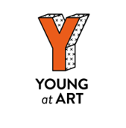
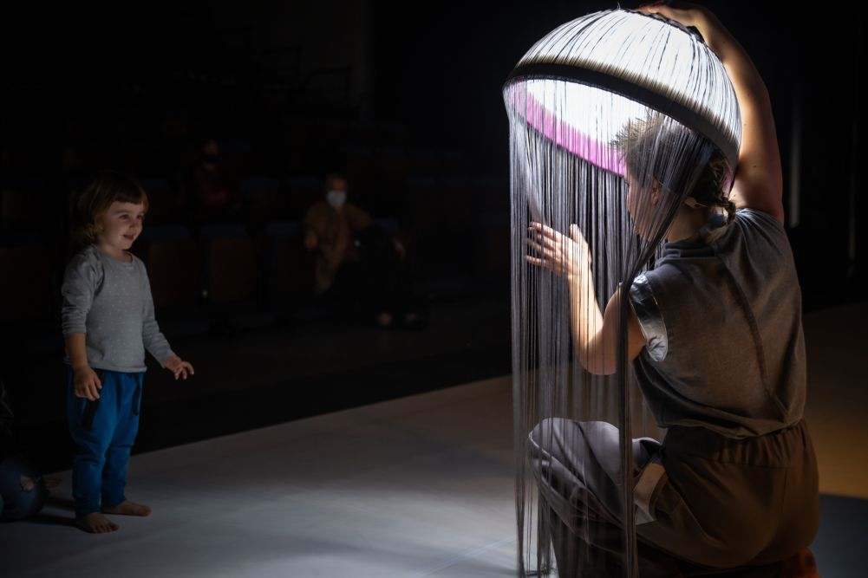

BEYOND UNIVERS
BY
ENGRUNA TEATRE

SHOW NOTES
Relaxed Performances create a welcoming environment that has been specifically adapted for individuals with an Autistic Spectrum Condition, those with sensory and communication disorders, those with learning disabilities and anyone who would benefit from a more relaxed environment including preschool children and people with dementia.

The performance is adapted in a variety of ways to reduce anxiety and ensure a safe and enjoyable live theatre experience:

- There is a relaxed attitude to audience noise.
- Reduced capacity so there is more room to move.
- The lights in the studio remain on low throughout the show.
- Sudden loud noises are softened.

Audience members are free to leave and re-enter the auditorium at any point.

SYNOPSIS

- Beyond Univers is 40 minutes long.
- It is suited to 3-14 year olds.
- It is performed in the Lyric Naughton Studio.
- The Naughton Studio has seating and standing space. The Naughton Studio is fully adaptable with light, sound and projection on request.
- Beyond Univers is an adaptation from the show UNIVERS, intended for neurodivergent audiences.
- It is a poetic sensory experience based on visual imagery, live music and movement, in which all the senses take a main role.
- People, bodies and objects that scatter, move around, connect with each other, and rearrange. Finding balance and harmony within the immensity of space. Even the smallest and seemingly most insignificant thing can change everything in the most unexpected way.
- If at any time you would like to take a break you can take a step away from the performance area or leave the theatre and come back whenever you’re ready. An usher will be there to help you.
- The Ushers are there to help you. They can show you where the toilets are. Ushers are good people to go to if you feel worried about anything in the show. You can speak to them before, during or after the performance.

QUIETER SPACES

We have dedicated several spaces across our building for you if you need to take some time out of the performance. Simply ask an Usher to help you get where you’d like to be.

· There is some space immediately outside of the Naughton Studio where you can take a breather if you need to. You may still be able to hear the performance or other people here.

· There is a dedicated Quiet Room, away from noise and people, with somewhere to sit and fully take time out.

WHEN THE SHOW BEGINS…AND WHAT TO EXPECT!

- The lights dim when the show is about to start
- Performers come on stage to begin the show
- People around you may quiet down in anticipation
- You will experience various sights and sounds during the show

- Beyond Univers is a performative experience.
- It is important that children or youngsters feel free to make the most of the experience.
- The focus of Beyond Univers is put on the audience, on how they interact and their ability to modify the artistic experience, so that the show becomes a unique new journey every time, for the audience, their relatives and for the artists.
- Beyond Univers aims to develop out of the Non-intervention of grown-ups / relatives in the free exploration of the audience.
- The title of this project differs from the original show because the experience and the dialogue that result from it are also different, aiming to widen our horizons.

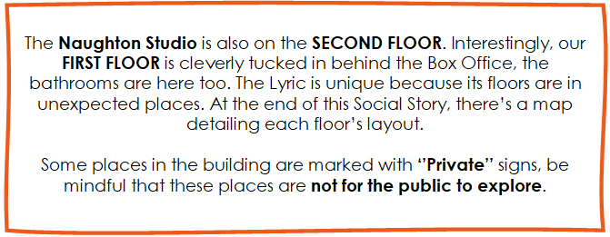

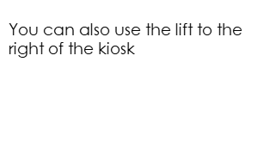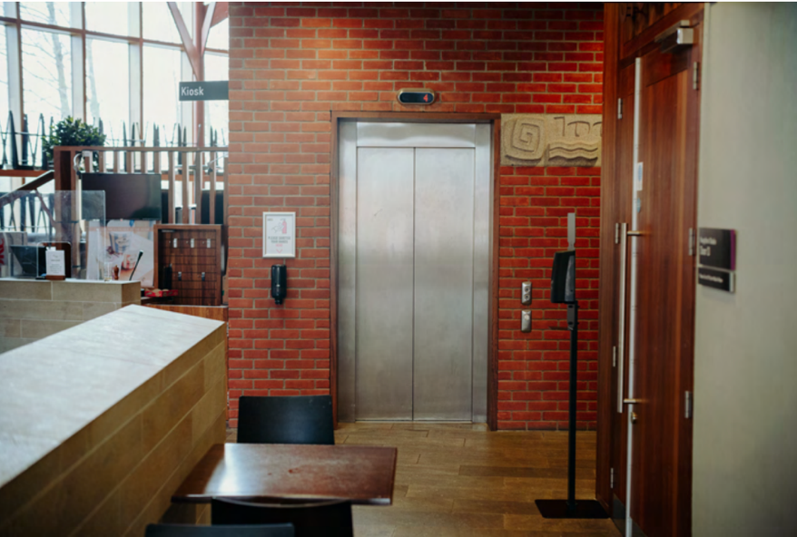

SHOW TIME

Where Your Show Takes Place…
