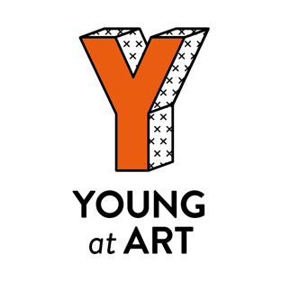
Young at Art (YAA) Collective Application

If you are in p4, p5, or p6 and love the arts,
the YAA Collective is for you!

Below you will find the application questions, these can be answered in a number of creative ways. You can make us a video entry, or send us a voice recording, or if none of those suit you can fill out the written form.

No matter what way you choose to apply, make sure you answer the questions below and remember with Young at Art there are no wrong answers, and we love silly! So be yourself, have fun, and show us how creative you can be!

Application Questions:
Note: If you’d prefer – these questions are also available in video format, which can be found on our website, www.youngatart.co.uk

- Please tell us:
  - Your name:
  - Your age:
  - What school you go to:

- Tell us about your hobbies. What do you love to do in your spare time?

- Have you ever been to see a show at the theatre? Or visited an art gallery? If so, what was the last thing you saw? Can you tell us about it?
Don’t worry if you haven’t been to the theatre or art gallery! Why not tell us about your favourite film, or comic book, a concert you went to, or a great book you read.

- What makes you creative? How do you show your creativity?

- What does art mean to you?
Don’t worry if you don’t have an answer for this yet – just be honest

- Tell us (or show us!) something else about yourself – now is your chance to show off!

Parent/Carer Information:

- Please provide us with a parent or carer:
  - Name:
  - Contact Email:
  - Contact Number:
  - Relationship to child applying:

- Does your child have any additional needs we should be aware of?

- Is there anything that could potentially make participating in this programme difficult for your child:
  - In person (for example, accessibility needs, access to transportation, etc):

  - Online (for example, access to broadband connection, or device):

We want to ensure that every child has an equal opportunity to join and participate fully in the YAA Collective, highlighting any potential barriers here will help us achieve this.

I ___________(Name) agree that if my child is selected as part of the YAA Collective, we will do our best to ensure attendance at all sessions throughout the year.

-----------------------------------------------------------------------------------------

Please send all completed applications, whether that’s a video, audio file, written form, etc., to education@youngatart.co.uk or to our the Young at Art Facebook messenger https://www.facebook.com/young.a.art.3

If you have any issues with sending your files, or any additional questions please contact our Education and Engagement Officer, Jackie, at education@youngatart.co.uk

Thank you so much for applying!

Many thanks to our funders for supporting the YAA Collective:

